EN. 605-702

Project 2: RouteMe  
Containerization  
Benjamin Huang

## Business Use Case:

This application stores a list of customers and addresses in a database and allows the user to optimize their route. The user can select which customers they need to visit so that they can be added to their route. The user can edit the route list by clearing the list and re-selecting the customers. With a potential list of customers selected, the user can generate the optimal route which is powered by Google Map API. The user can add more customer addresses through the form at the bottom of the page. The application will use Google Map API to geocode the address into latitude and longitude which is used to generate the optimal route.

Note: The website is live and working as of the writing of this report at: <http://routeme-alb-1630067429.us-east-1.elb.amazonaws.com/> However, it may be taken down because of costs.

# Architecture Diagram

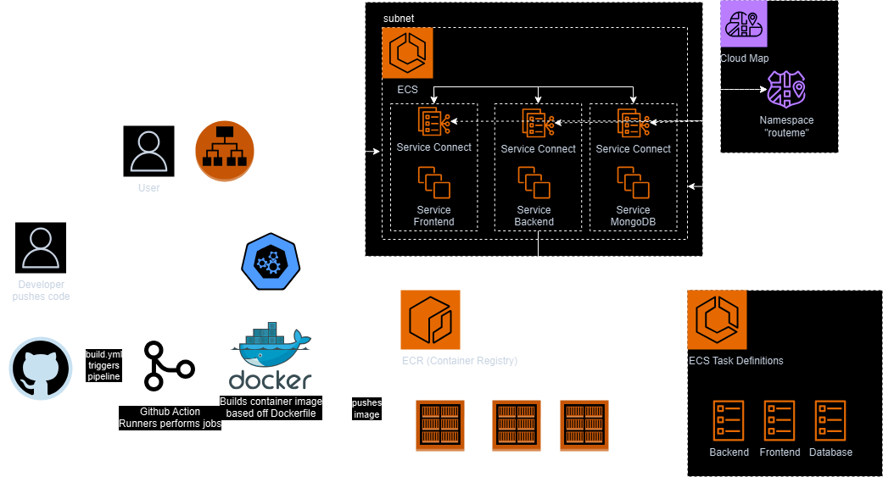

## Tech Stack and Deployed Resources:

The code for this project is deployed to GitHub.

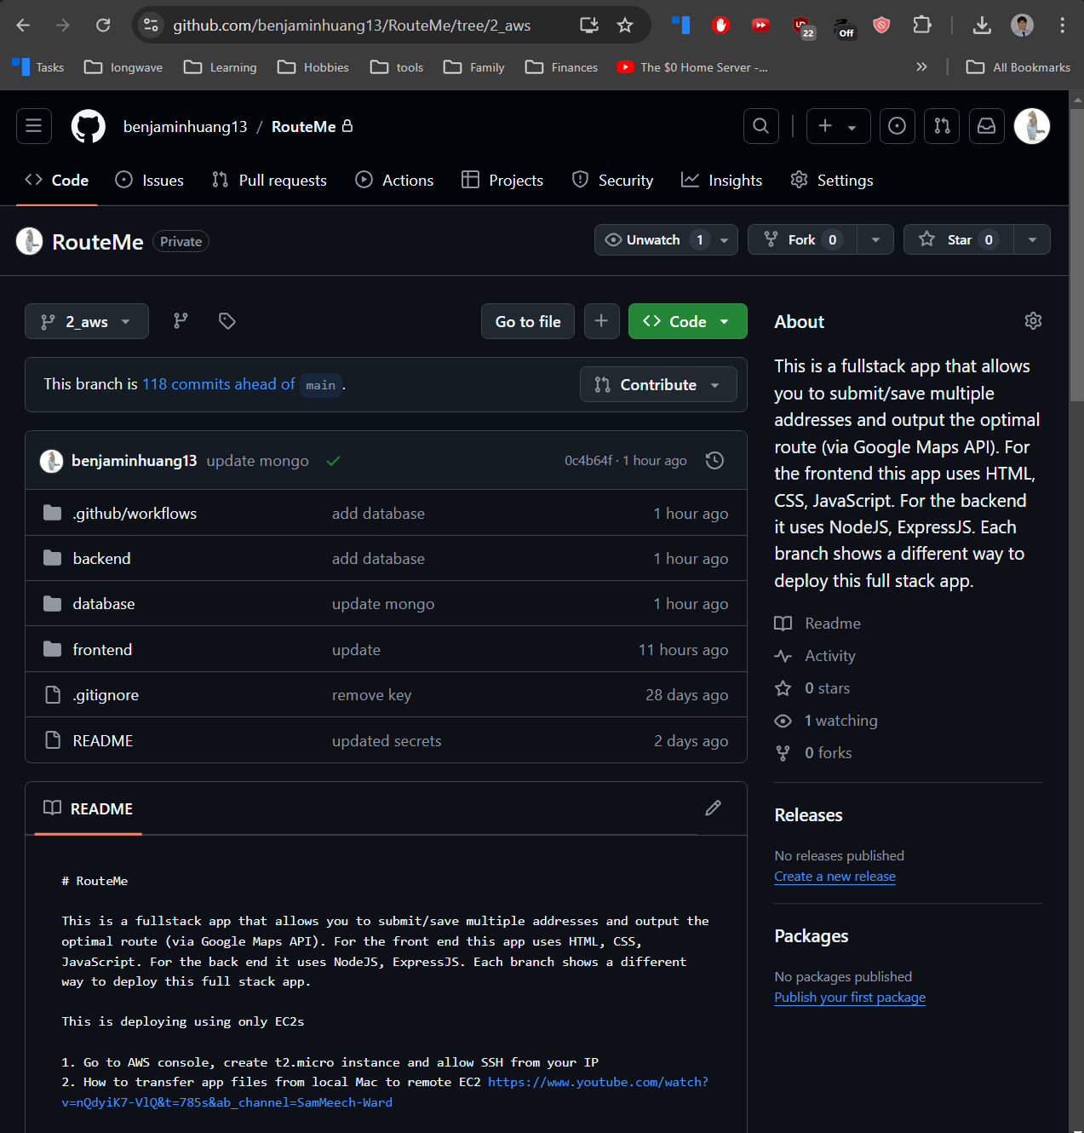

### How to store secrets in GitHub Actions

Secrets are stored in GitHub Actions secrets and variables. This allows secure storing and transit of secrets onto the docker images.

* To initiate GitHub Actions create **build.yml** file in the **.github/workflows/** directory of the repo
* To upload secrets. Go into GitHub settings > Secrets and variables > Actions and add your secrets
* To use these secrets, see the build.yml and Dockerfile.

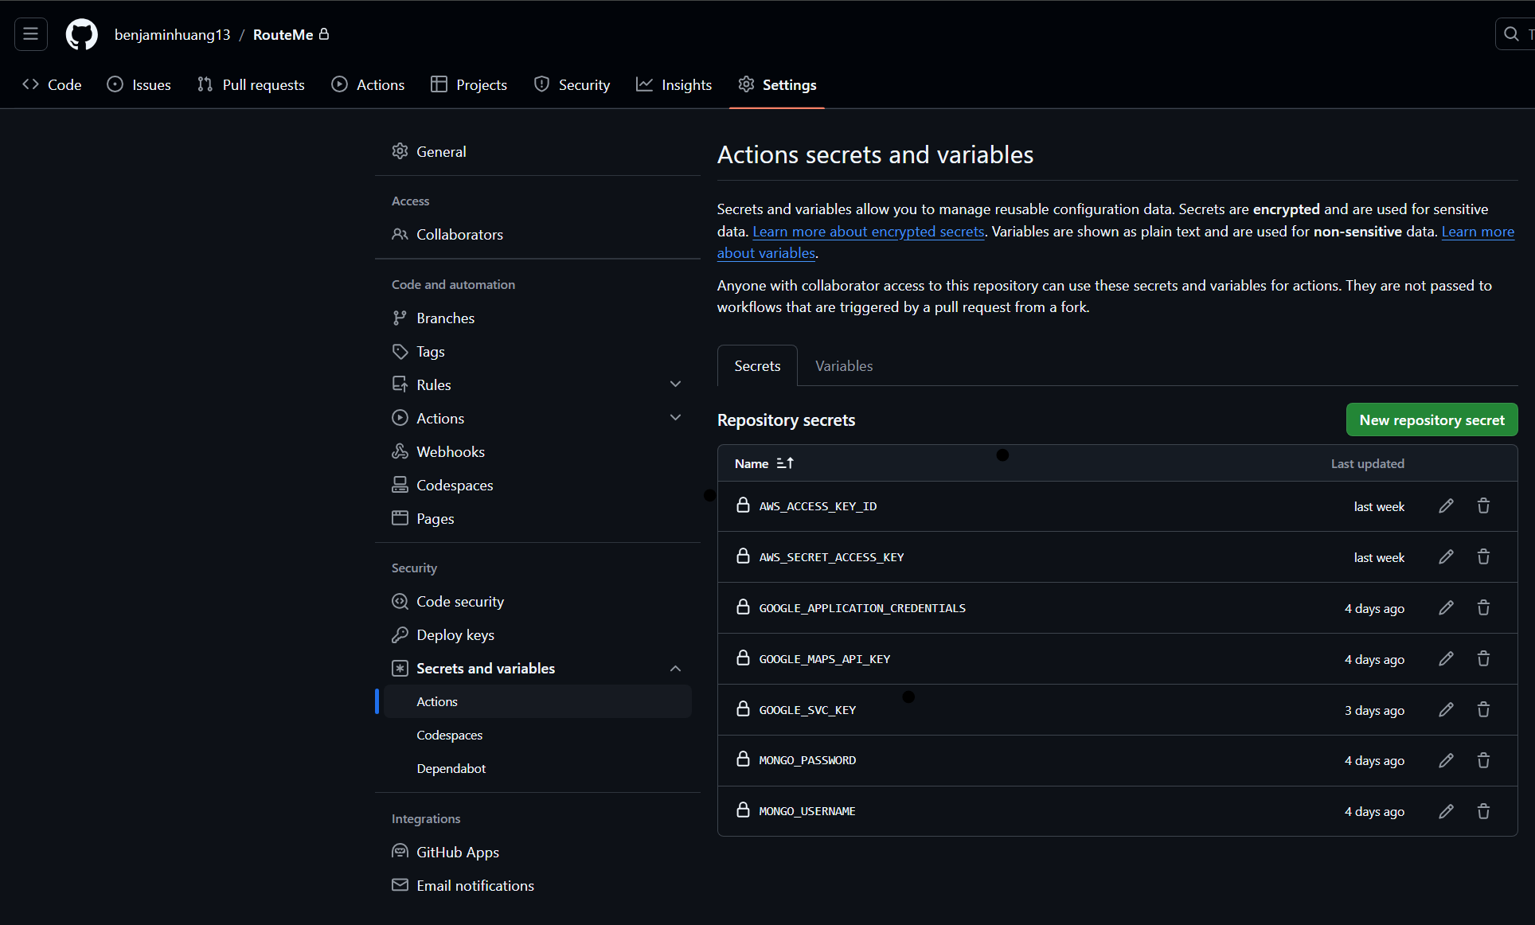

GitHub Actions is used for CI/CD. The build.yml file uses Docker and the Dockerfile to build three images (frontend, backend, database) and is triggered to run every time a push happens.

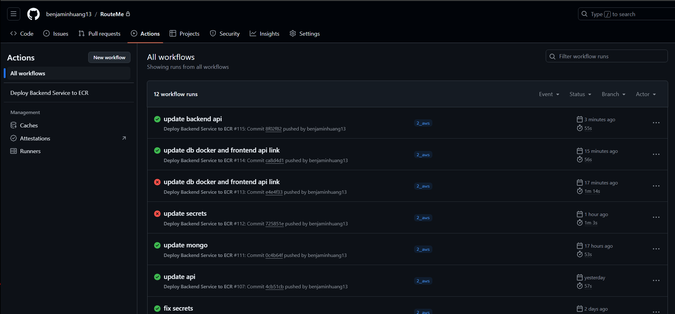

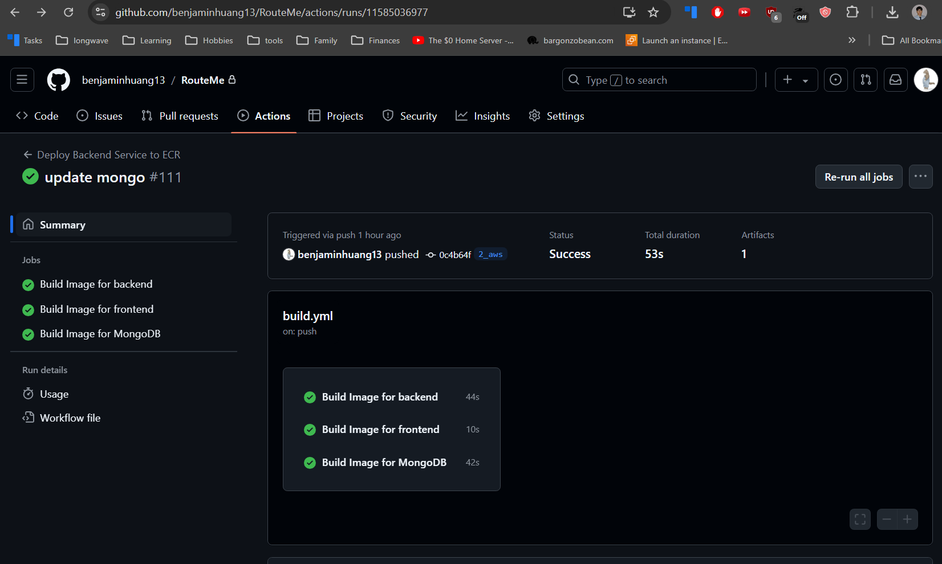

### How to start GitHub Actions

Below is the workflow for the frontend build process. More details can be found in the build.yml file and Dockerfile in /frontend directory.

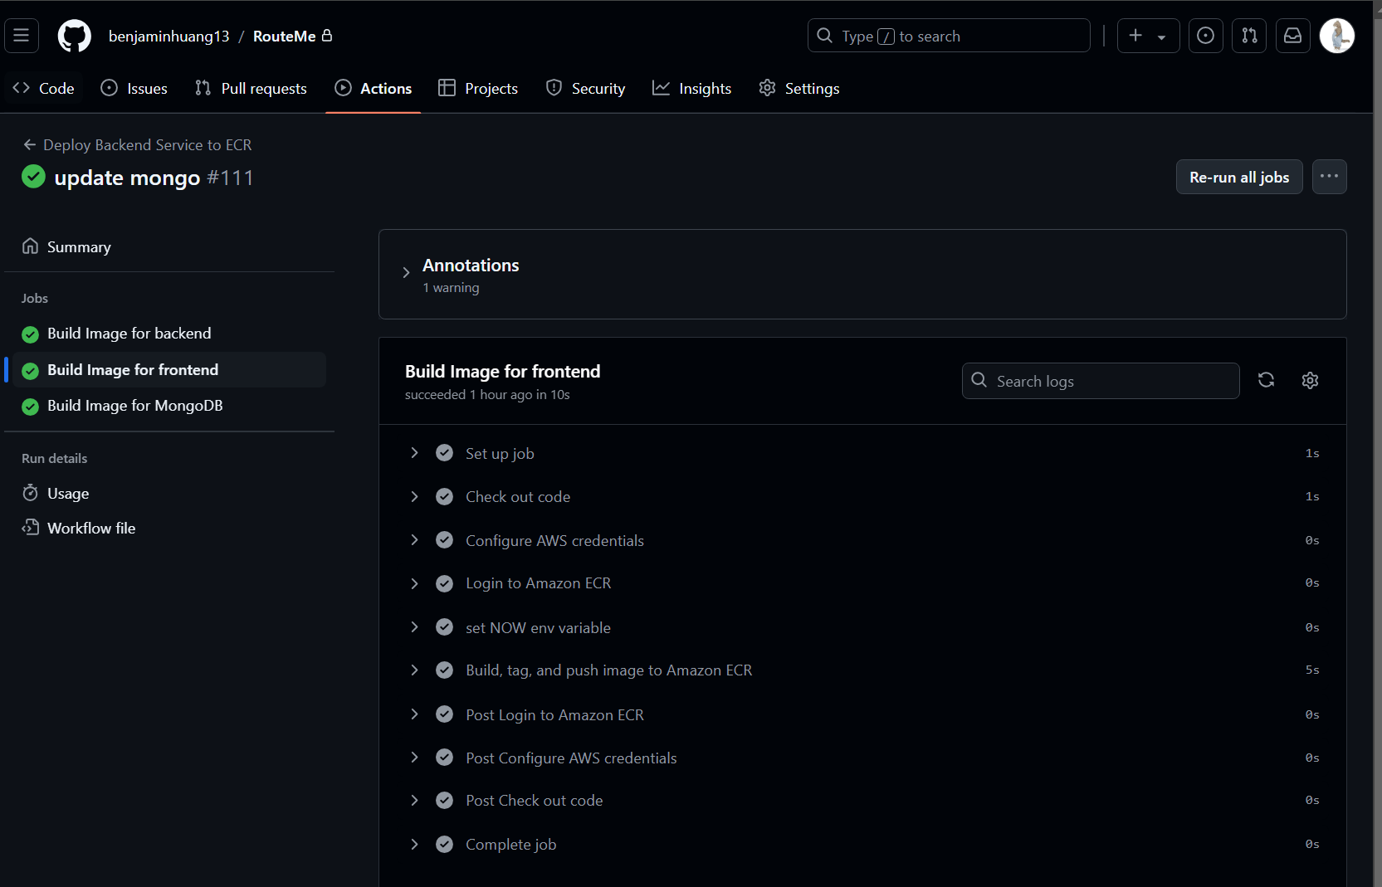

Backend workflow:

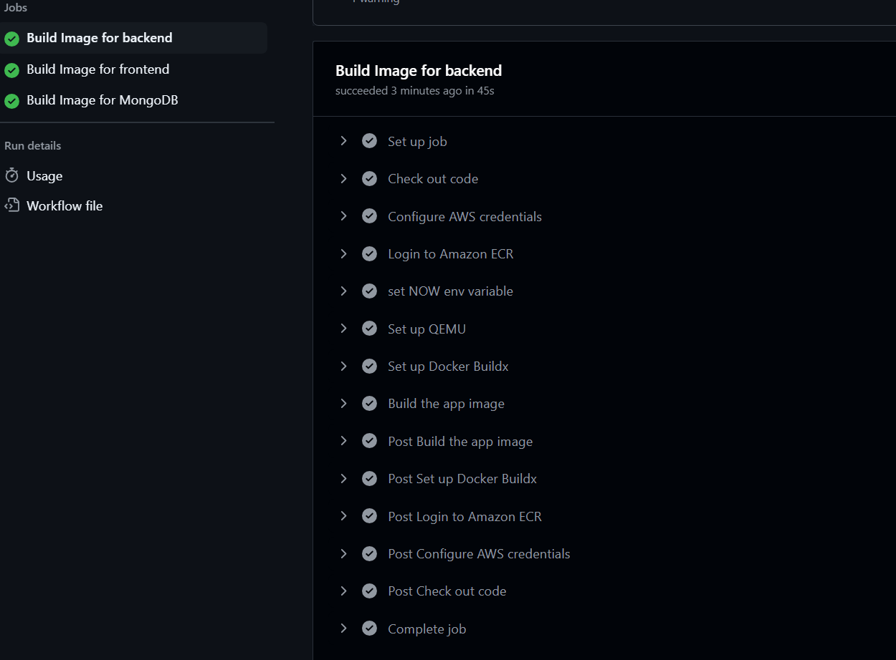

This copies the code in the repo:

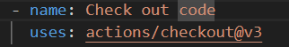

This uses GitHub secrets to get the stored AWS credentials to login to your AWS account:

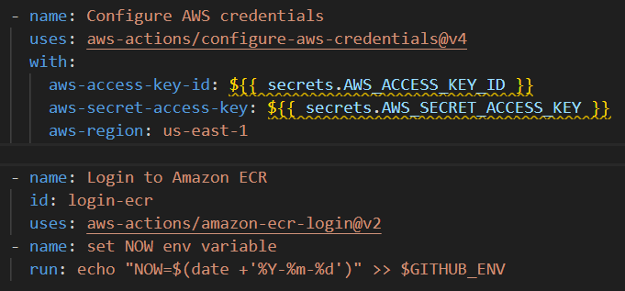

This builds the image using Docker and adds the GitHub secrets to the Docker build

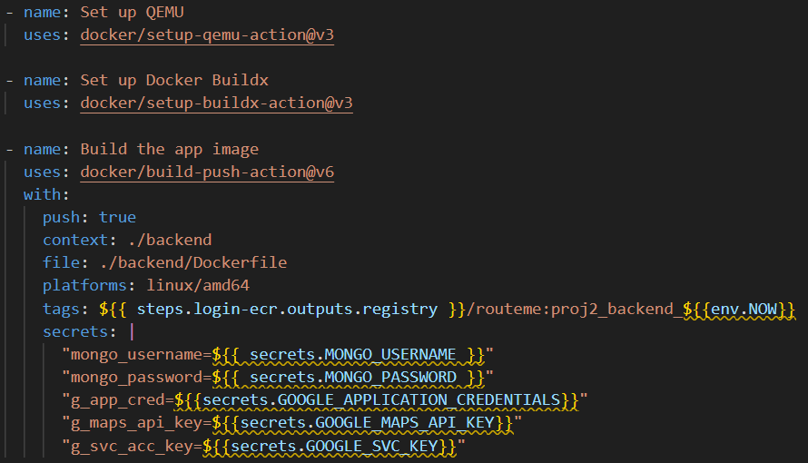

### How to create AWS Access Key

The CI/CD pipeline authenticates into AWS and the three container images are then tagged and uploaded to AWS Elastic Container Registry (ECR).

For GitHub to authenticate into AWS and upload the image, create AWS Access Key:

1. Go to AWS IAM
2. Click “Create User”  
   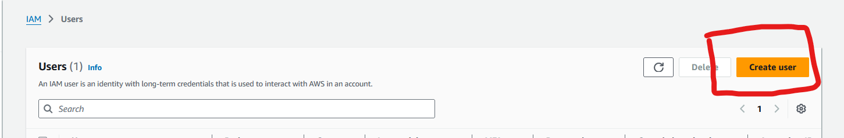
3. Specify the name and click “next”:  
   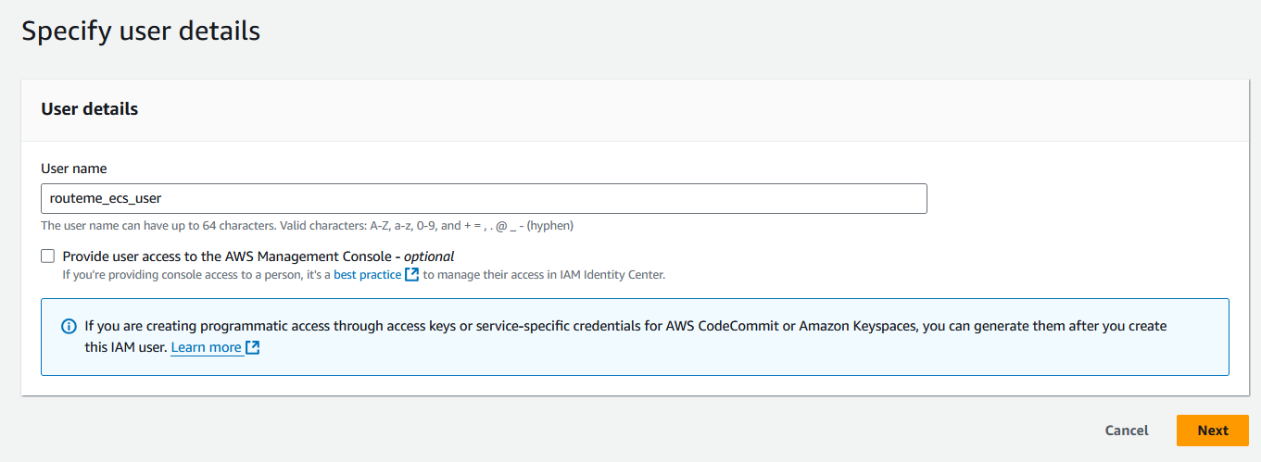
4. Click “Attach policies directly” and search for AmazonEC2ContainerRegestiryFullAccess and check it:  
   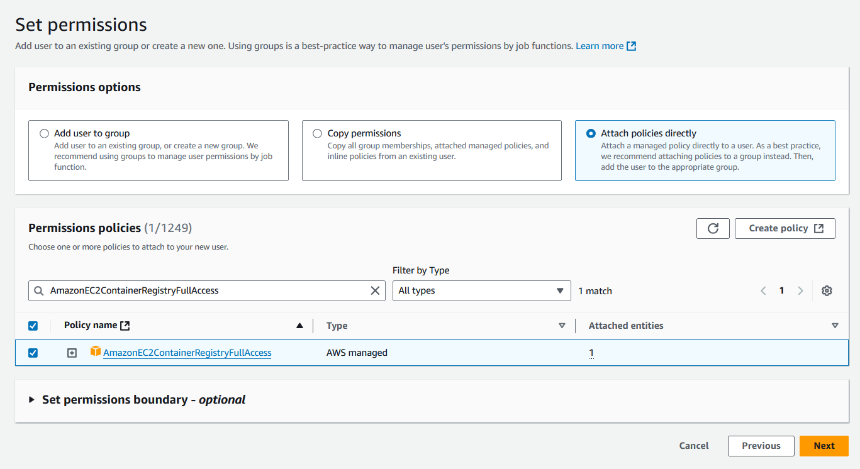
5. Review and click “create”:  
   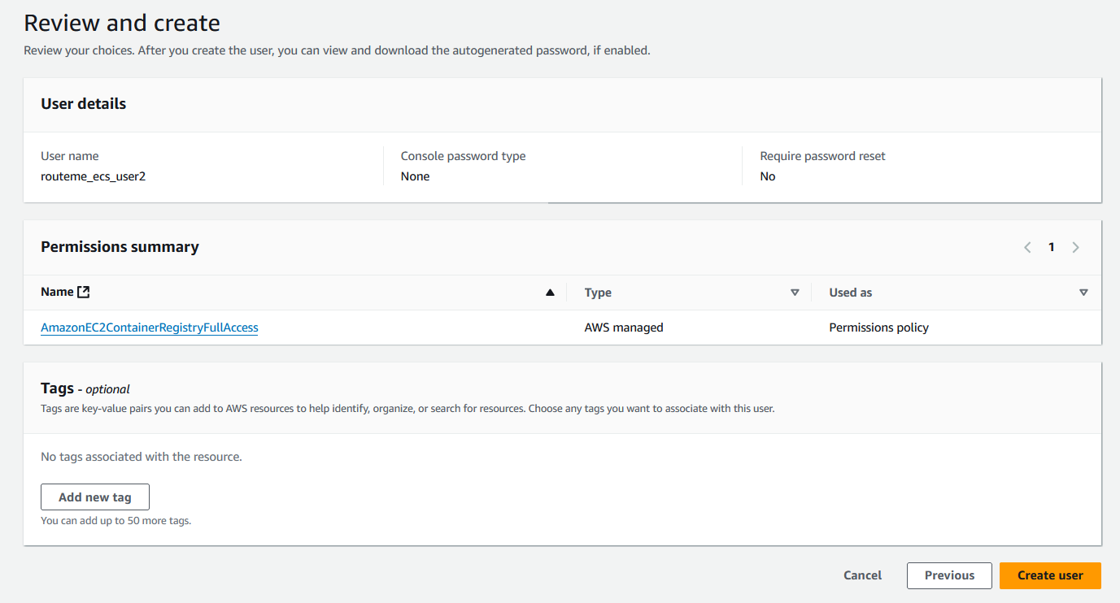
6. Click on the User you just created. And click “create access key”:  
   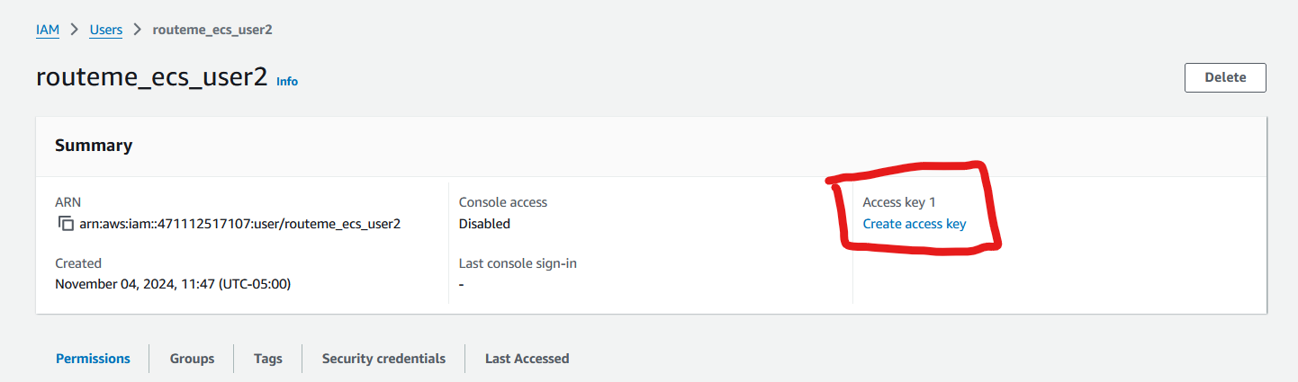
7. Click on “third-party service”, check the agreement and click “Next”:  
   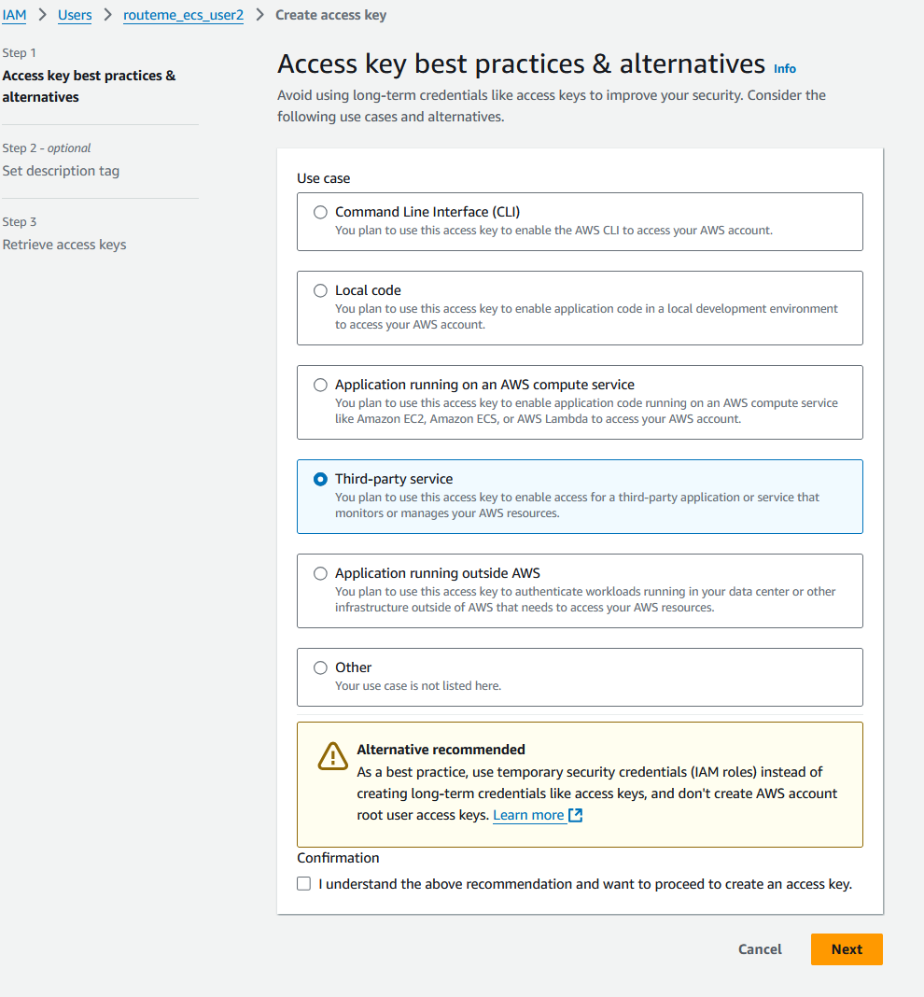
8. Click “create” and then save the Access Key and Secret access Key locally.   
   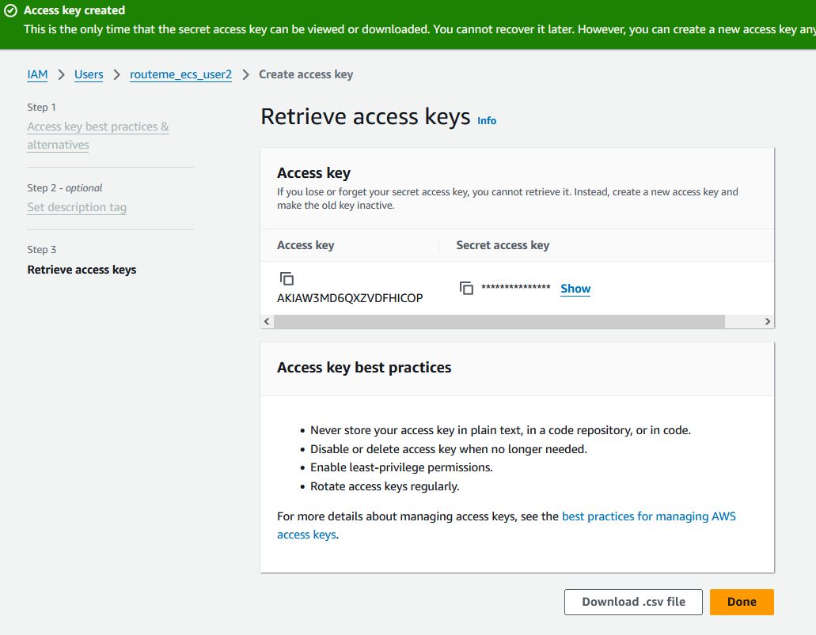
9. Click ‘Done’. Go to GitHub Actions secrets from earlier and upload the access key and secret access key. (This was shown earlier)

### How to Create Elastic Container Registry (ECR)

1. Go to ECR: 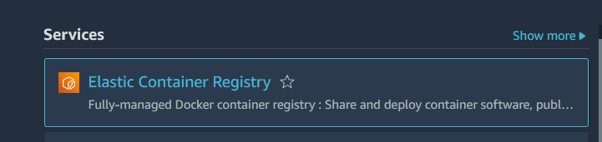
2. Click “Create repository”:  
   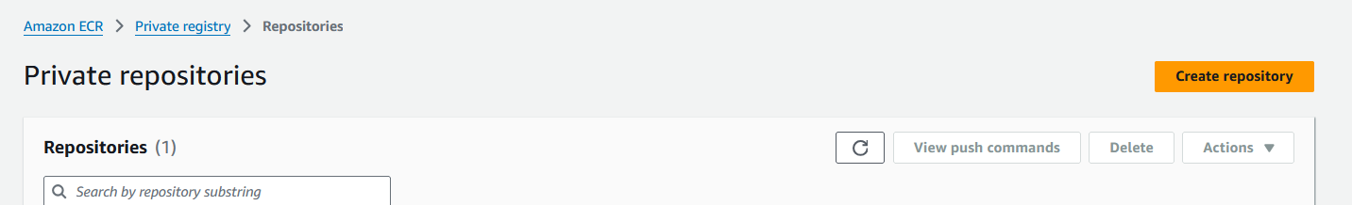
3. Name the Repository:  
   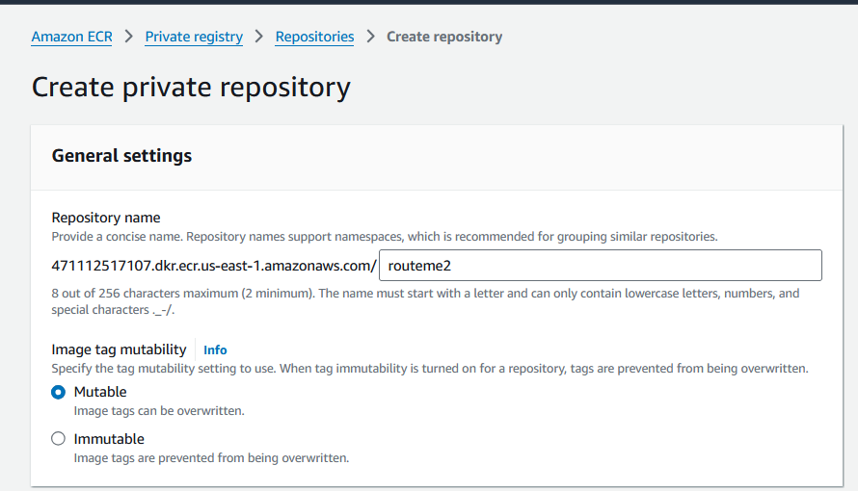
4. Use the URI in the Github actions build.yml file to dictate where the image should be uploaded:  
   

Example of what the repo looks like: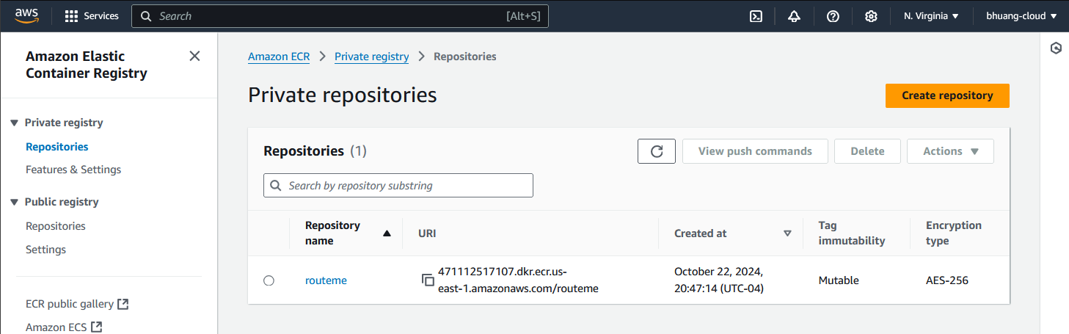The different images can be seen below when you click the repo:  
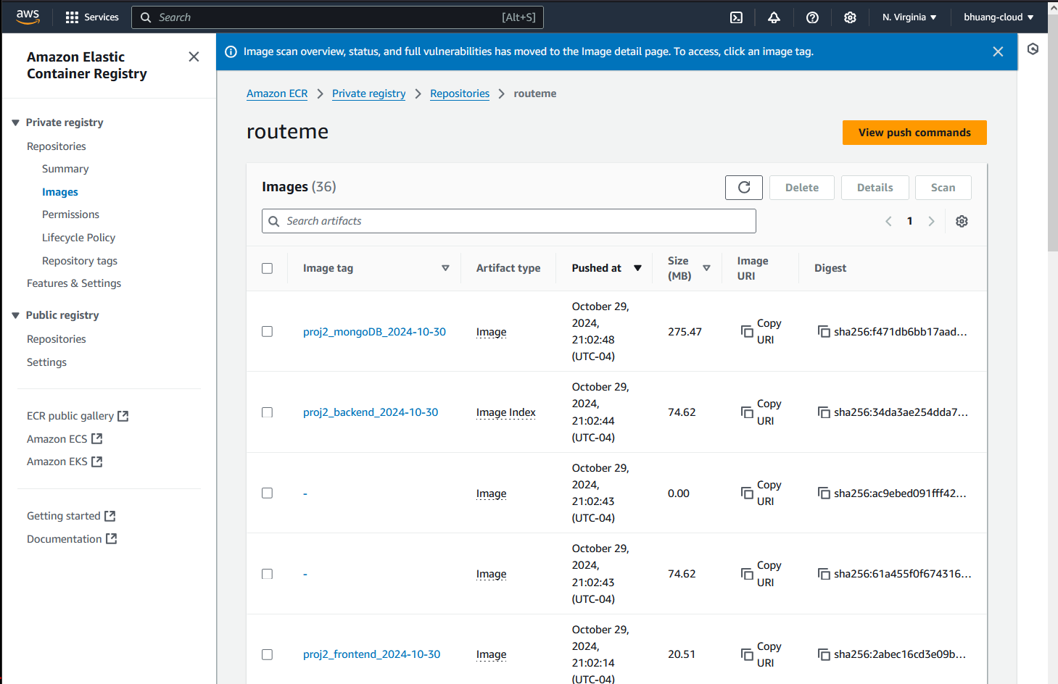

### How to use the images in ECR for ECS:

For this project three ECS Task Definitions are created to outline how to build the ECS services.

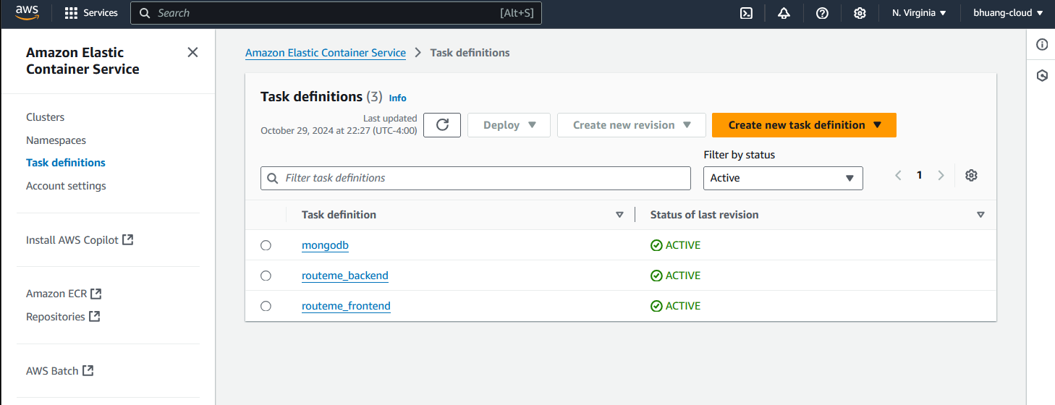

For the Frontend service:

1. Go to ECS services
2. Click “create new task definition”:  
   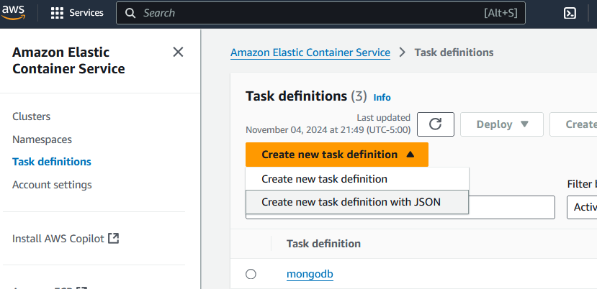
3. Name the Task definition family:  
   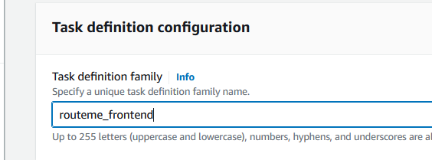
4. Only enable “Amazon EC2 instances” for launch type. Choose “bridge” for network mode. And Lower the CPU and memory to save costs:  
   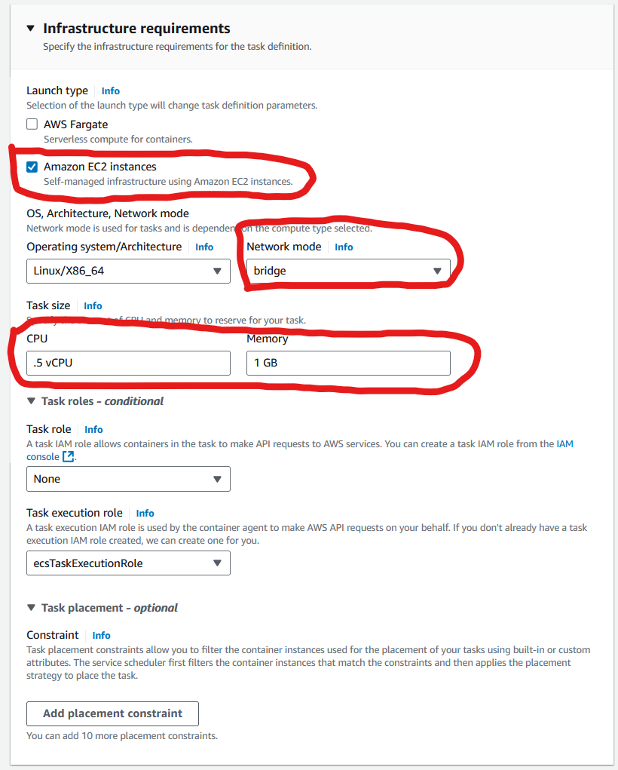
5. Name the container details. Past the URI of the frontend image that was built and uploaded to ECS. Add the Port mappings.  
   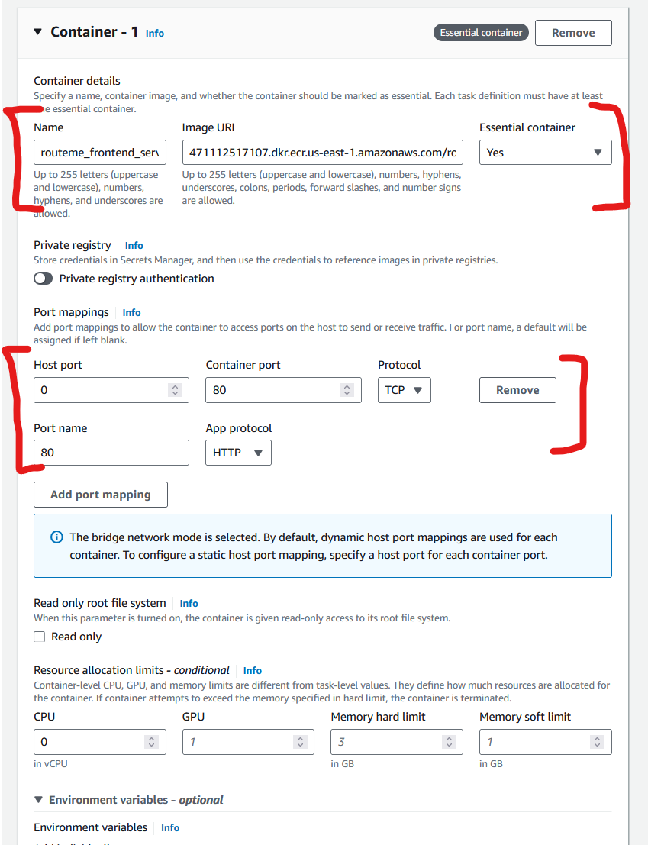
6. Leave everything else as default and Click “create”. It should look like:
7. 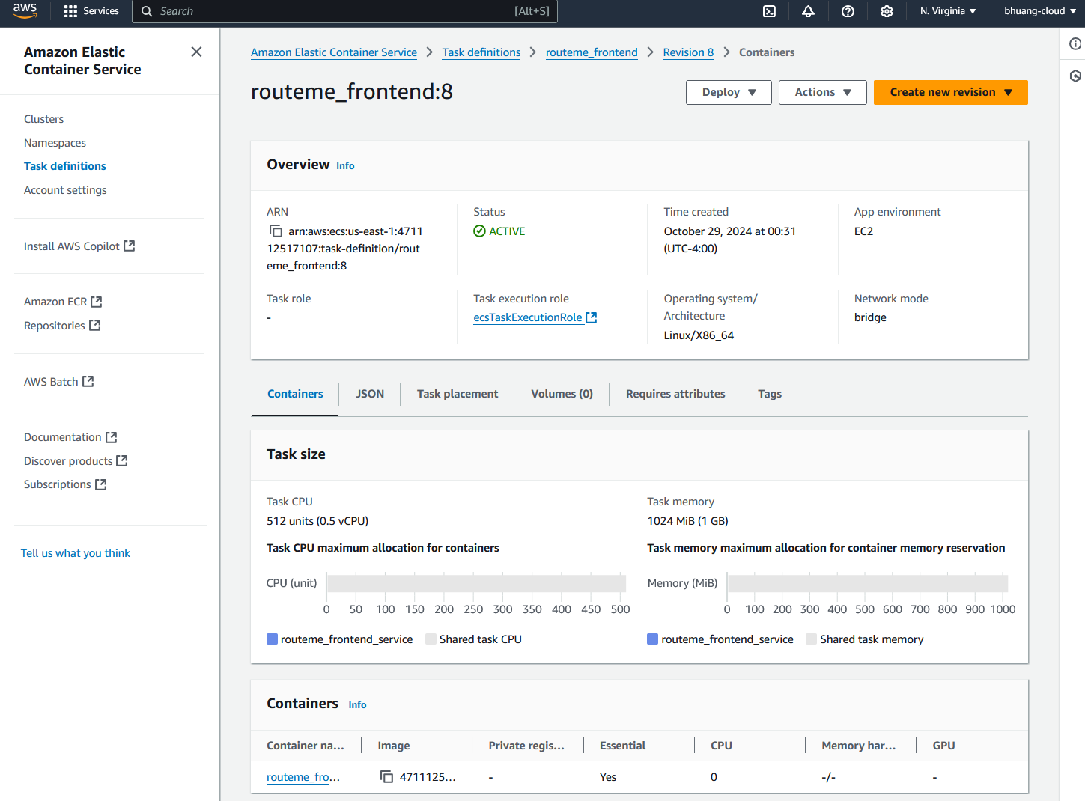
8. For the backend service, do the same with these details:  
   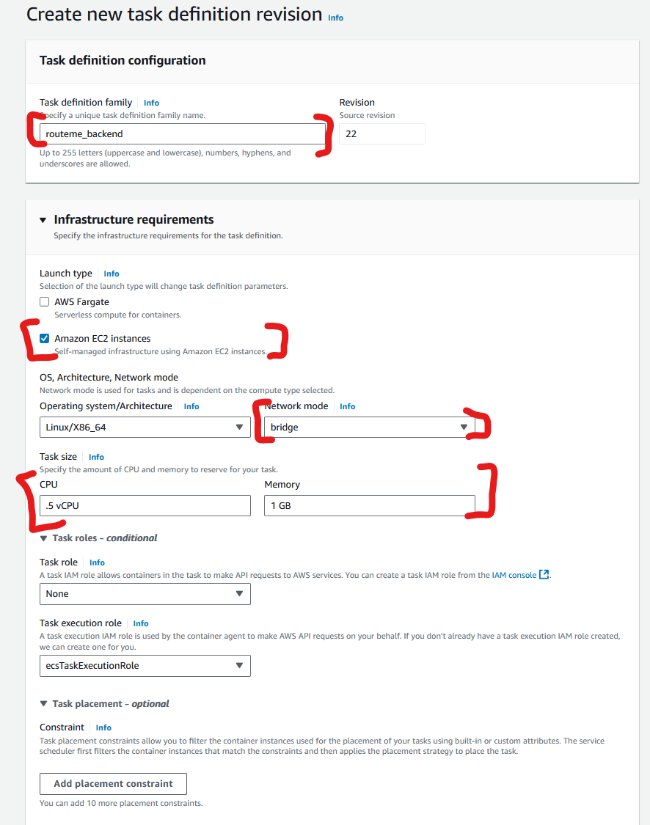  
   Make sure to use the backend service image URI.  
   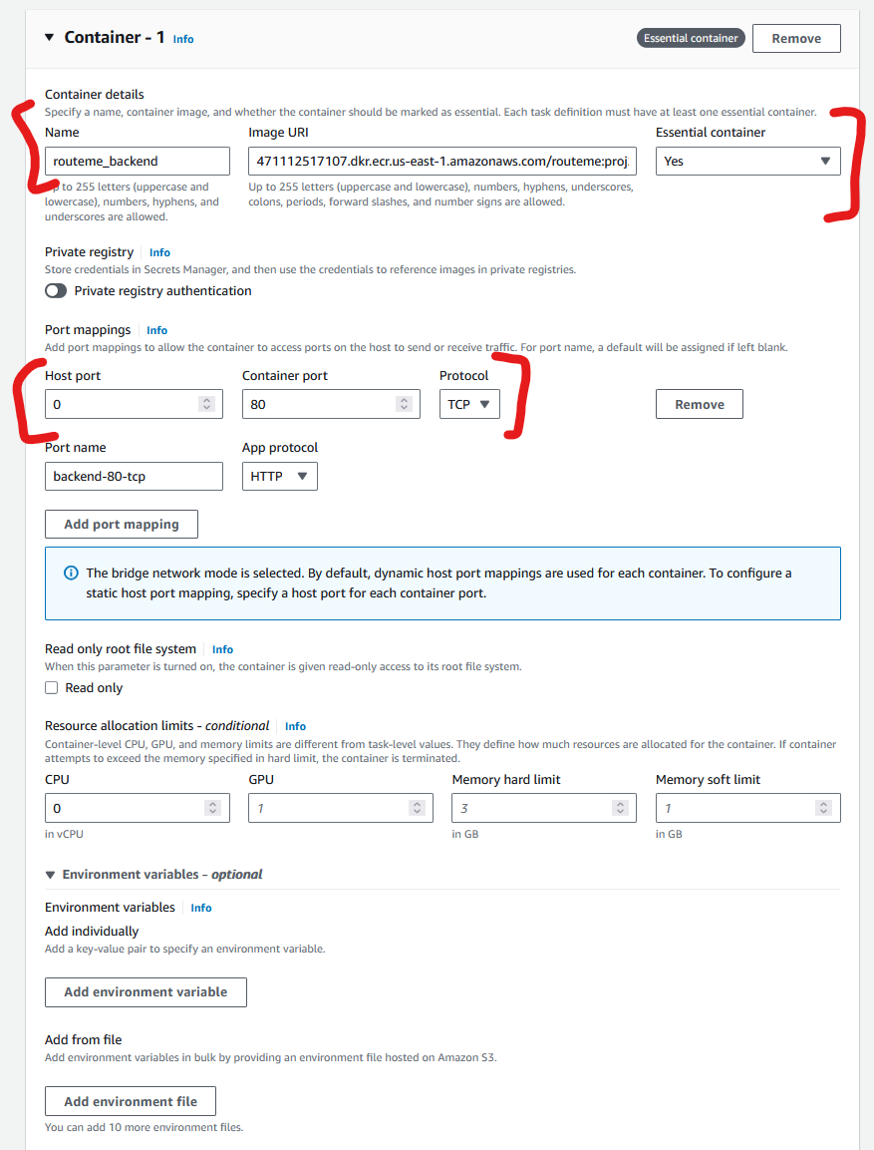
9. Click “create” and it should look like:  
   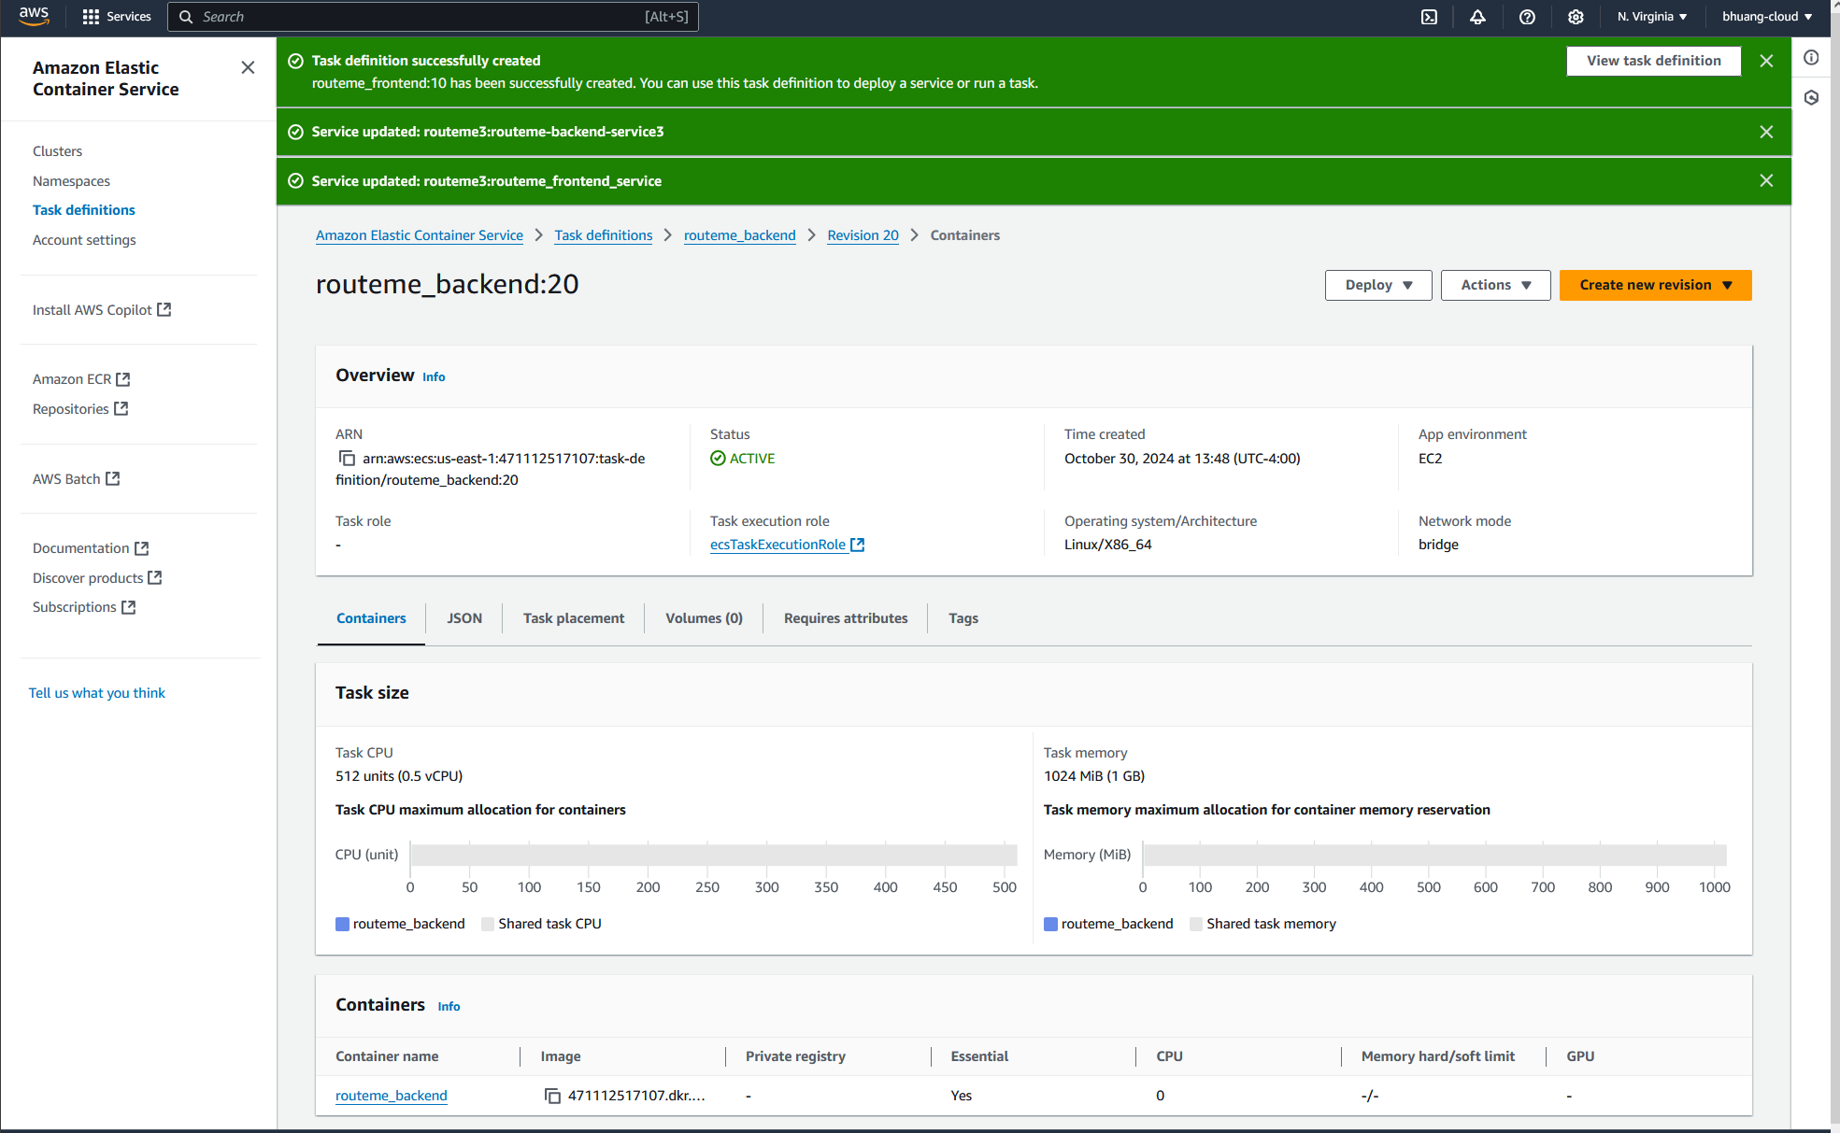
10. For the MongoDB service, create another Task defintion:  
    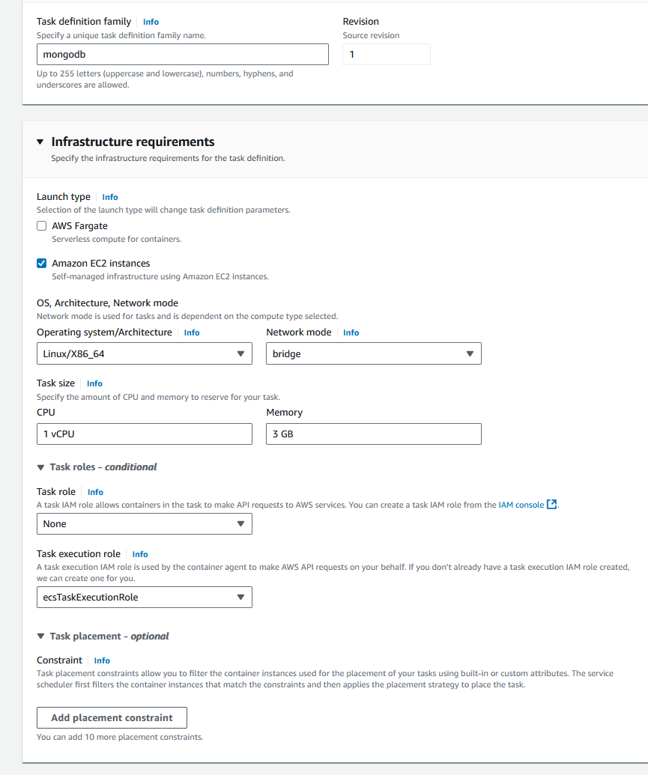  
    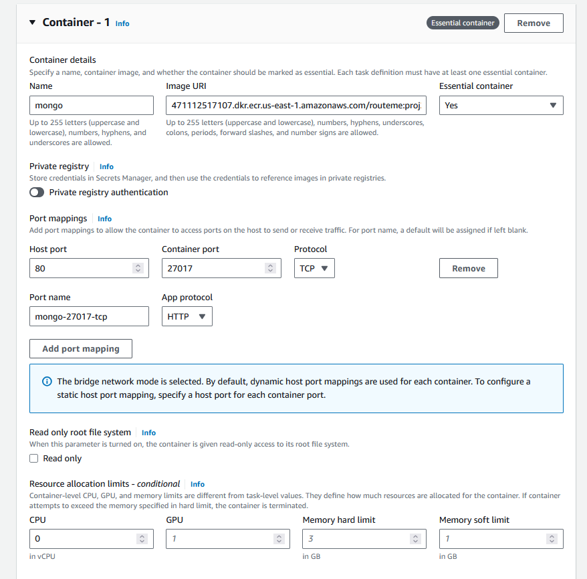
11. Click “create” and it should look like:   
    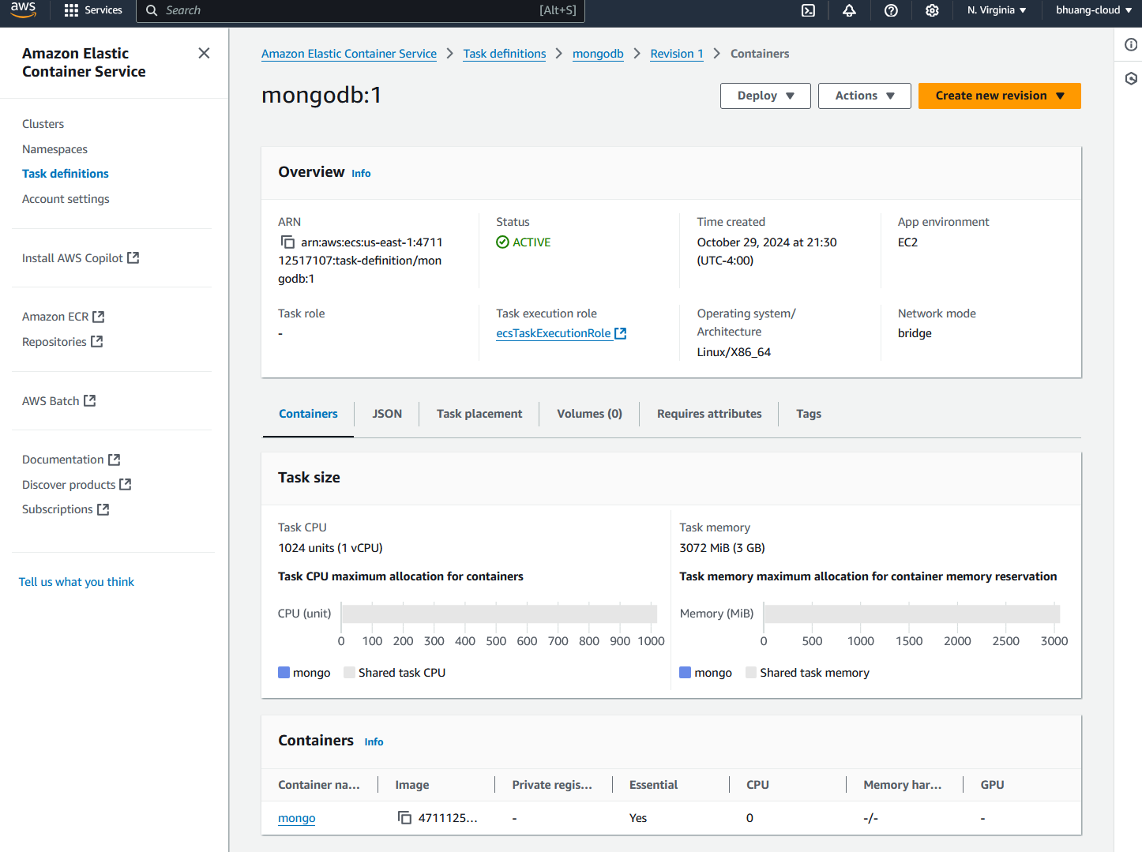

This project is hosted in an ECS Cluster called “routeme3”. Using EC2 deployment and bridge network mode.

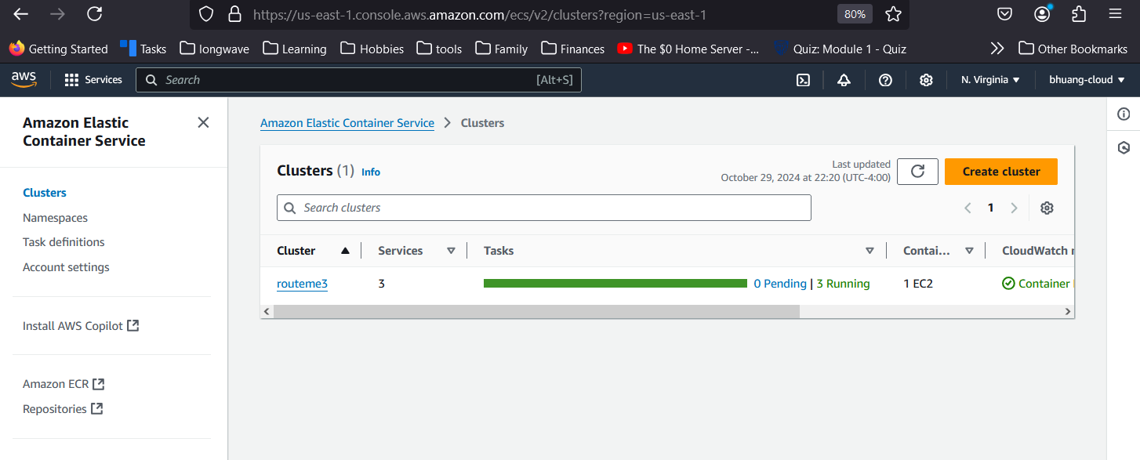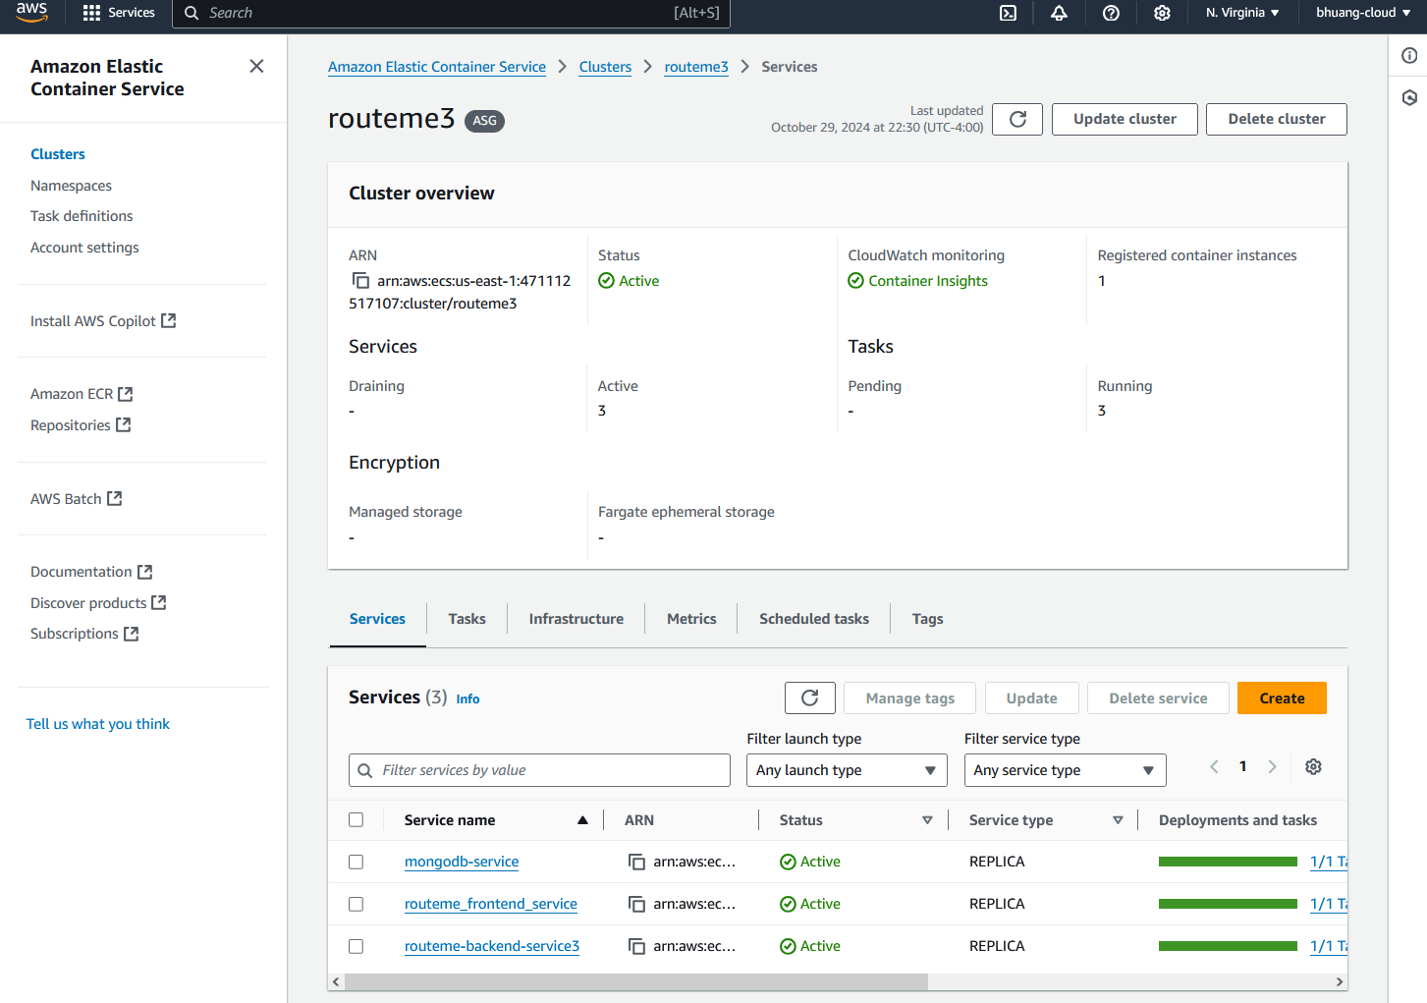

Context about the different services.

* The application’s frontend is built using HTML, CSS, JavaScript and is hosted in the ECS cluster as the service “routeme-frontend”.
* The application’s backend is built using NodeJS and ExpressJS to create a Data Access Object (DOA) API. This is hosted in the ECS cluster as the service “routeme-backend”.
* The document-based database is hosted in the ECS cluster as the service “mongodb”, and it is used to store customer data. The backend server sends requests to the database to store or retrieve customer data.

These 3 services are created in the ECS, each service can be seen below.

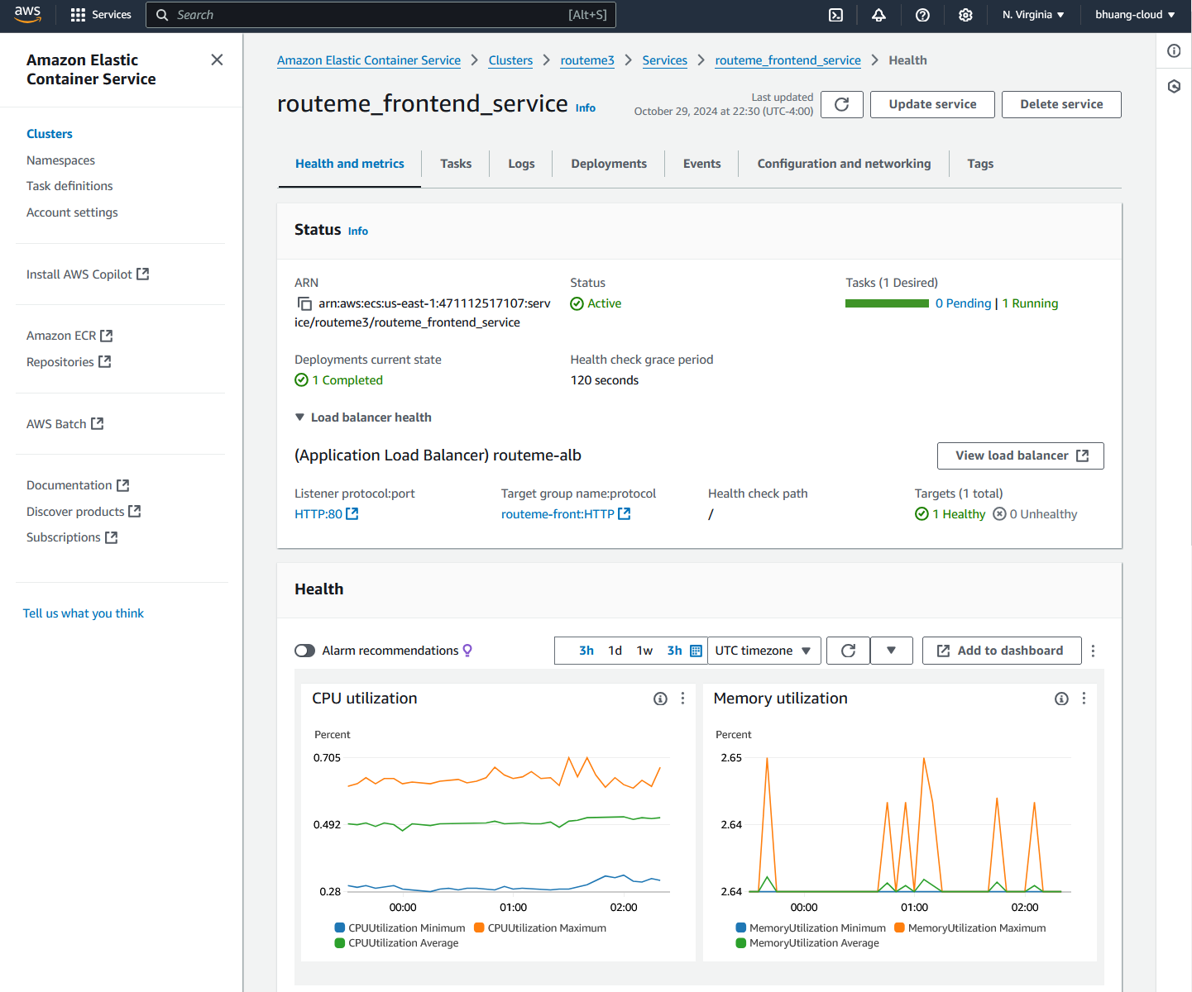

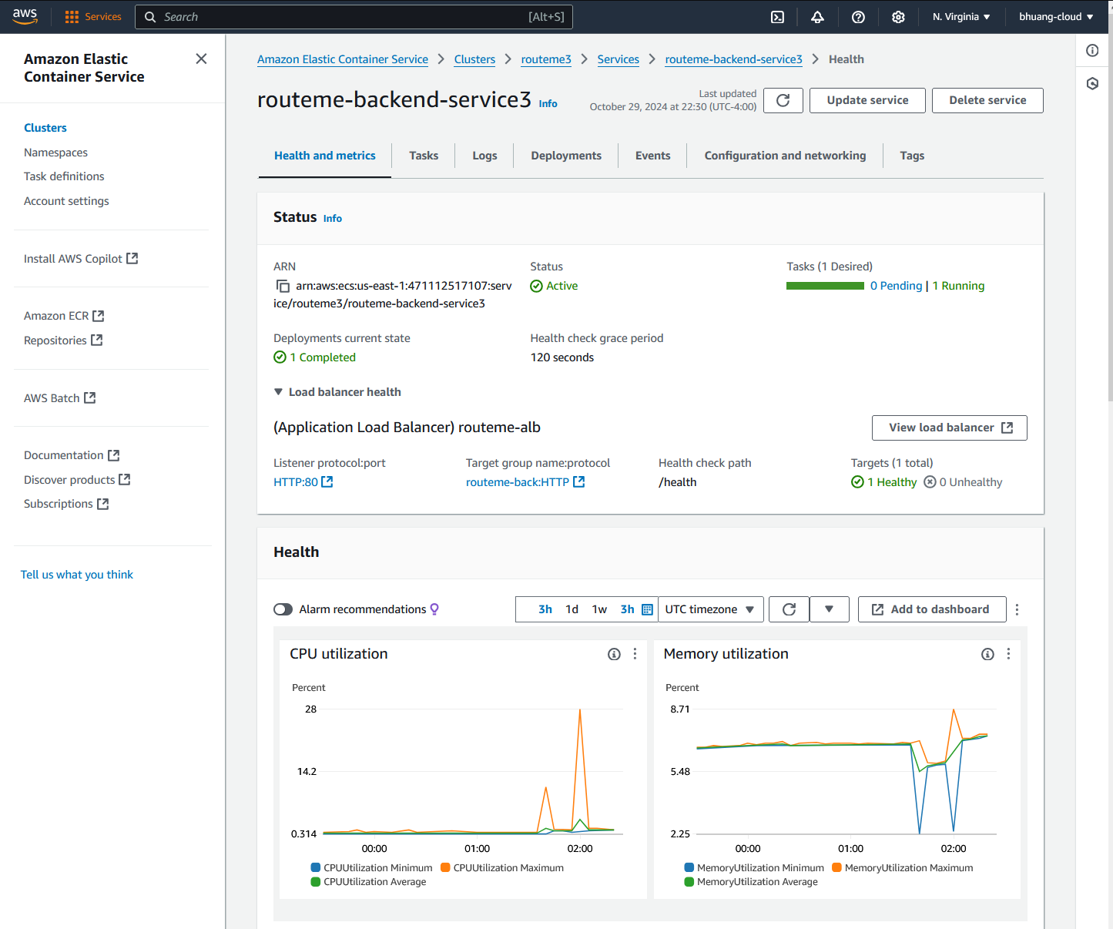

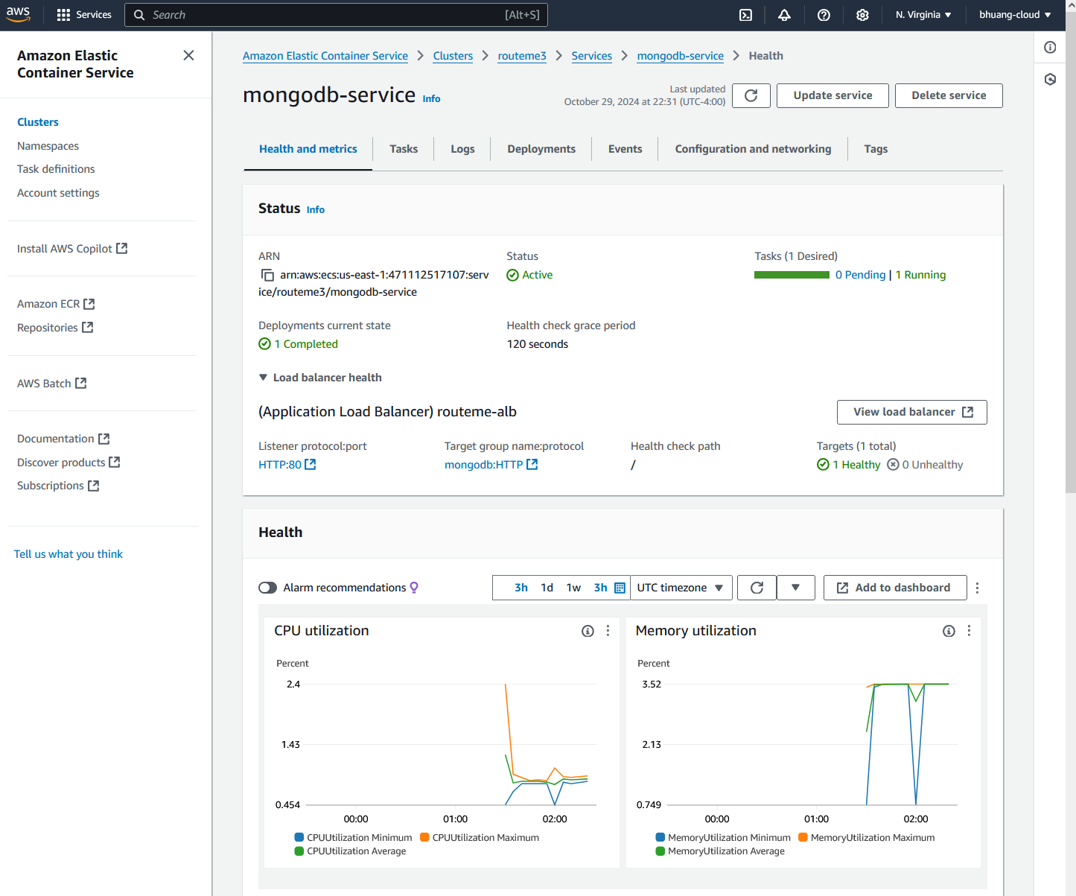

For communication between services, Service Connect is used to connect to the backend services and MongoDB service.

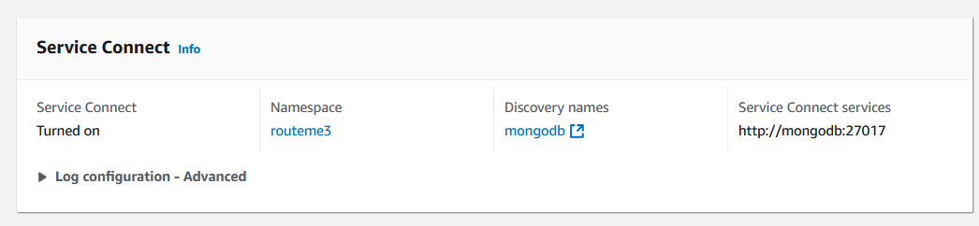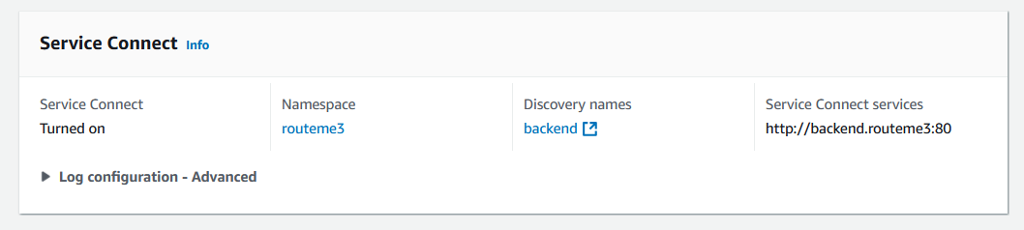Which uses the ”routeme3” Namespaces

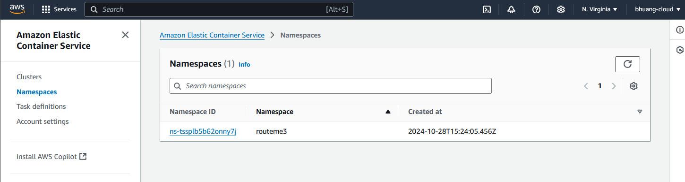

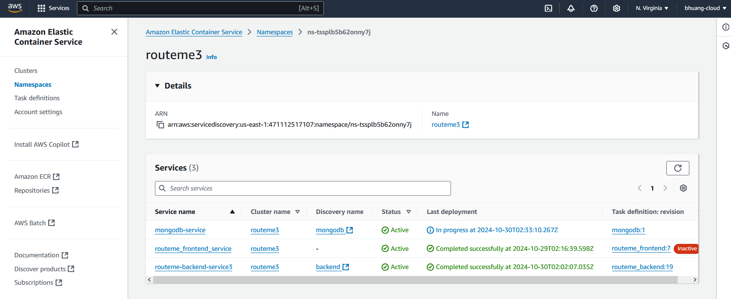

### How to Create Security Groups

1. Before we create the Cluster, we need to create security groups. Go to “EC2” service.  
   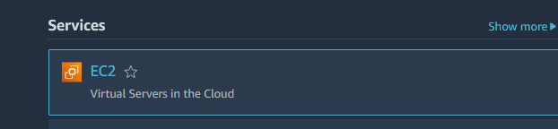
2. Go to “Security groups”:  
   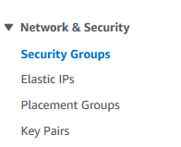
3. Click “Create security group”  
   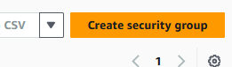
4. Add the name, description, use the default VPC, and add an inbound rule to allow HTTP traffic from anywhere. Leave the outbound rule as all traffic to anywhere. Click ‘create security group’  
   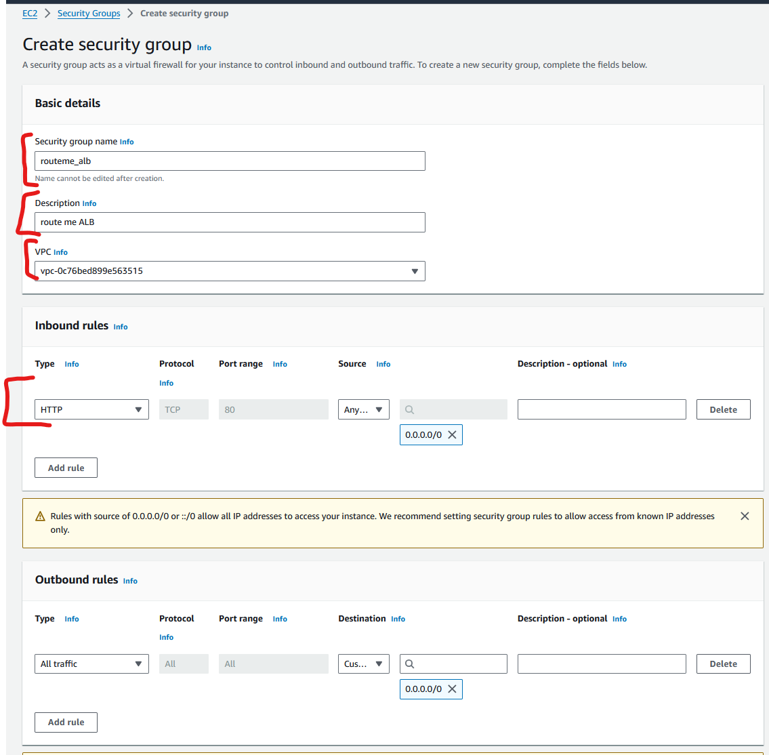
5. Click “create security group” again to make a second security group and use the following details. Add name, description, and use the default VPC. Add inbound rule that allows all TCP from the security group you created earlier. (you can search it by name).
6. Click ‘create’ and now you should have 2 security groups.

### How to create Application Load Balancer for application

1. Go to EC2 service:  
   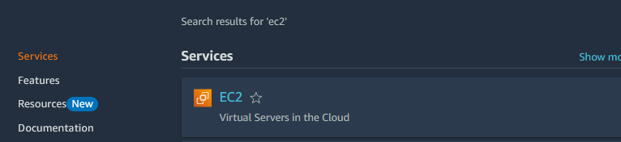
2. Go to “load balancers”:  
   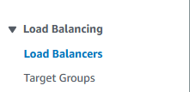
3. Click “create load balancer”:  
   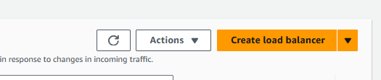
4. Click “create” for Application Load Balancer:  
   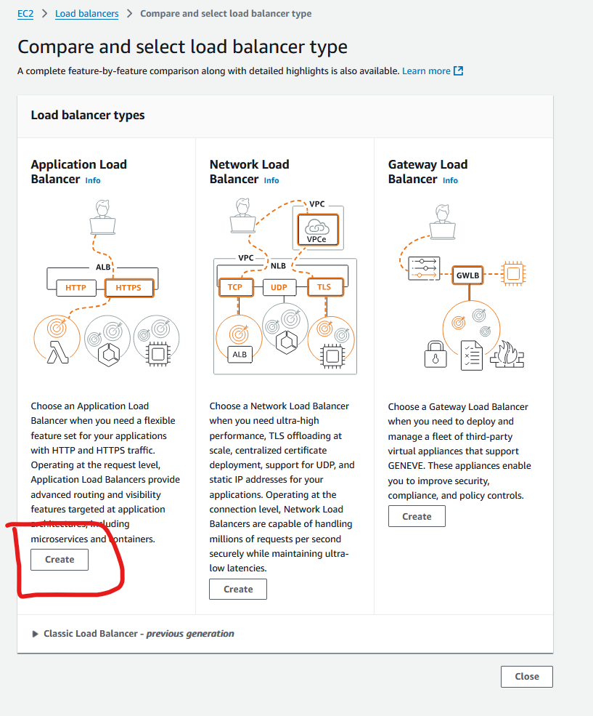
5. Name it:  
   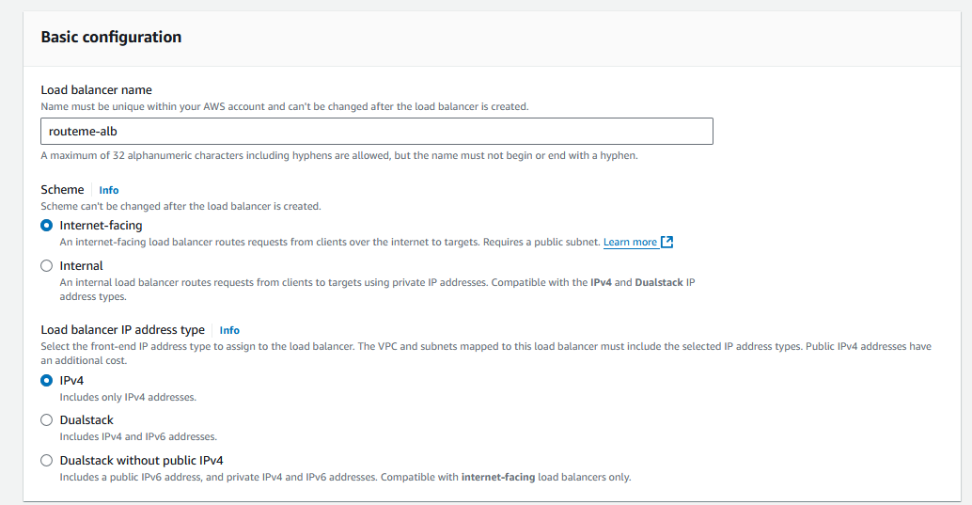
6. Choose default VPC and AZ zones:  
   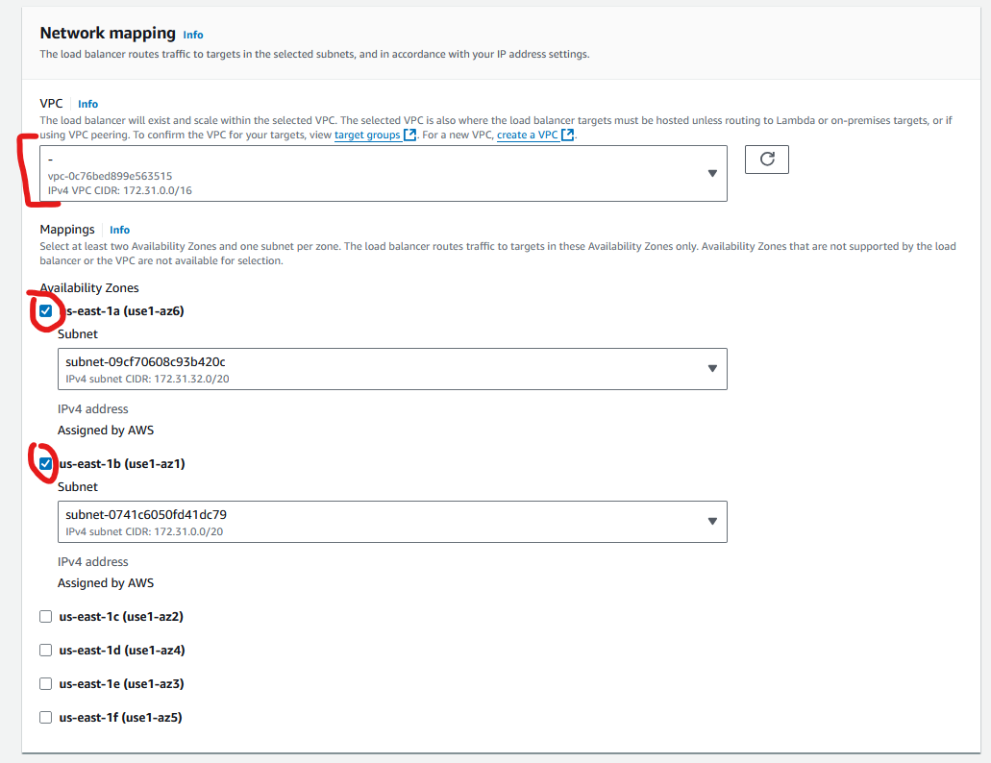
7. Choose “ecs” security group created earlier:  
   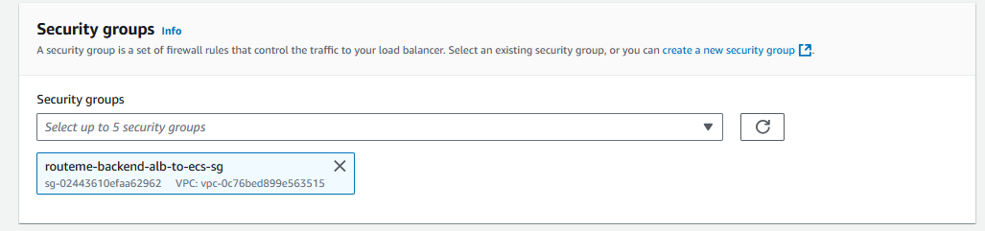
8. 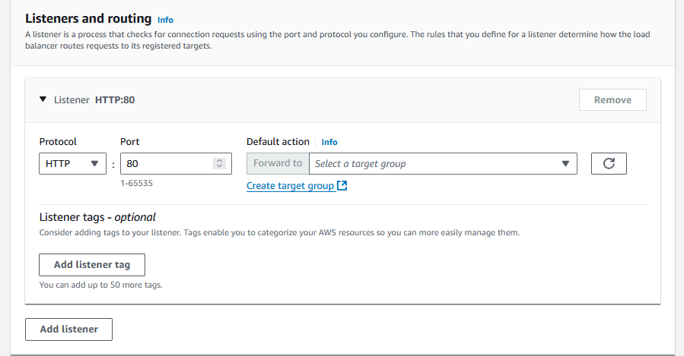
9. review and click “create”  
   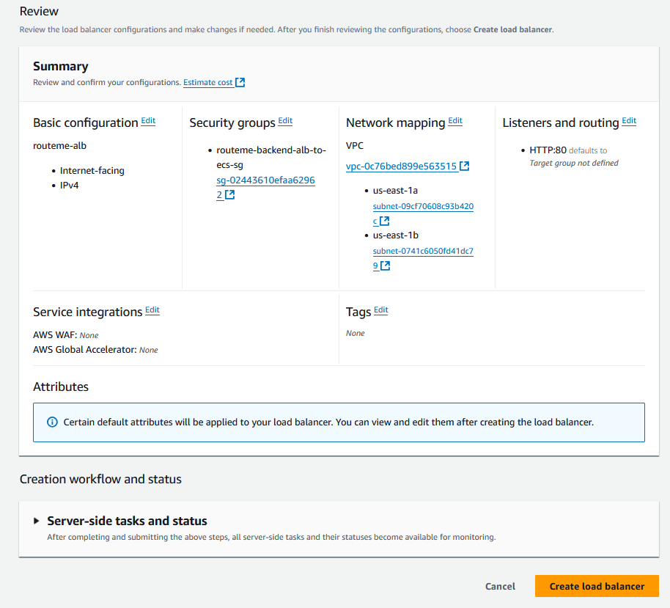
10. Now you have an ALB: 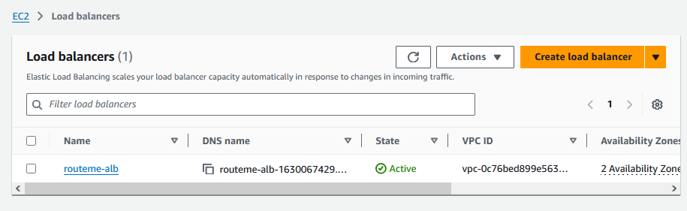

### How to Create ECS Cluster

1. Go to ECS
2. Go to “Clusters”:  
   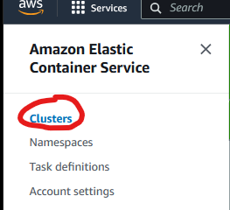
3. Click “create cluster”:  
   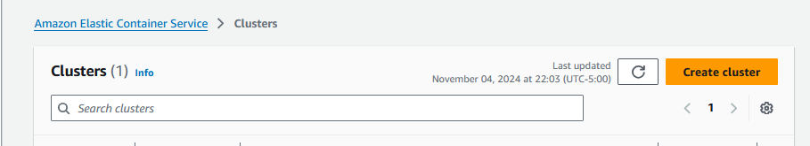
4. Name the Cluster:  
   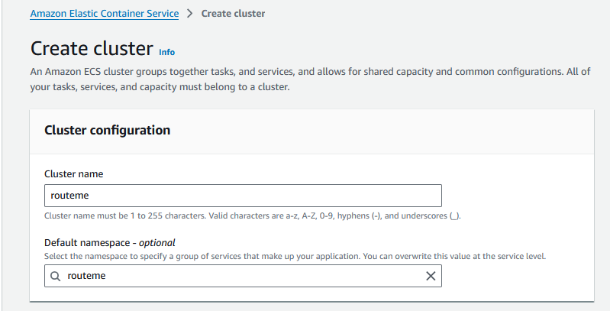
5. Add infrastructure details:  
   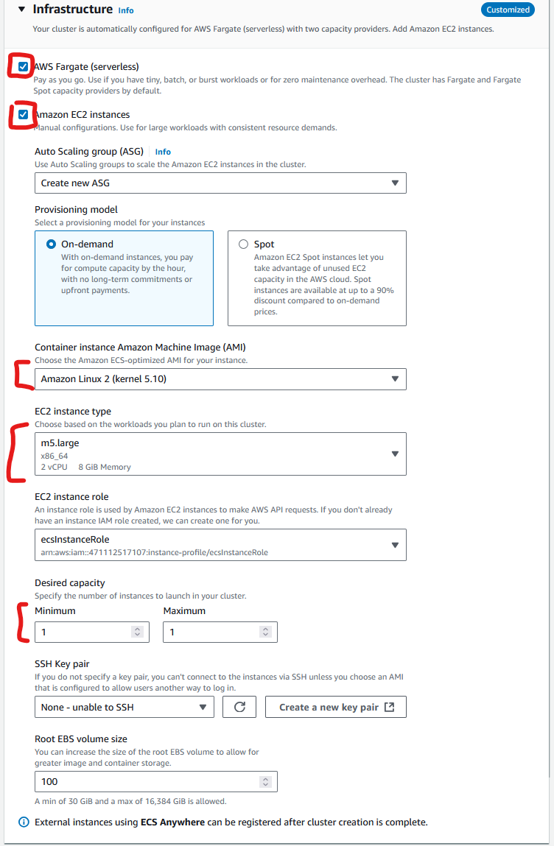
6. Use the following Network config and click “create”:  
   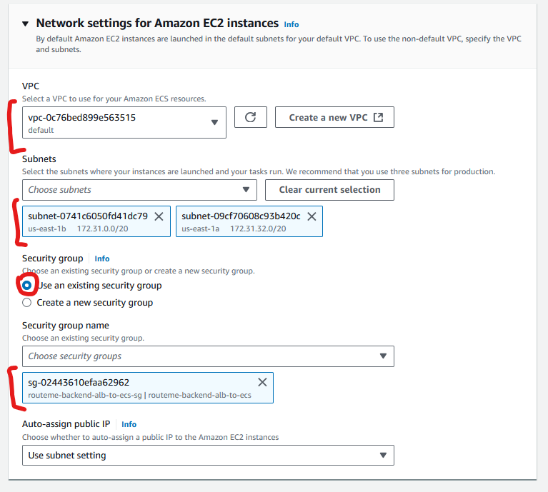
7. You now have a cluster:  
   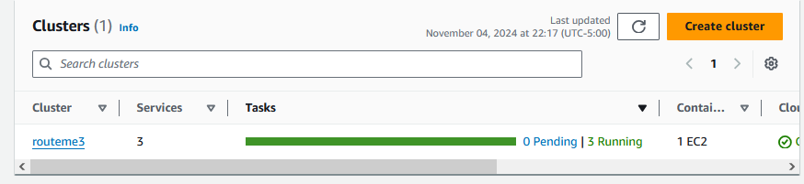
8. To create the frontend service. Click on the Cluster you just created. And click “Create” under services:  
   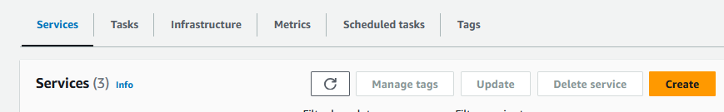
9. 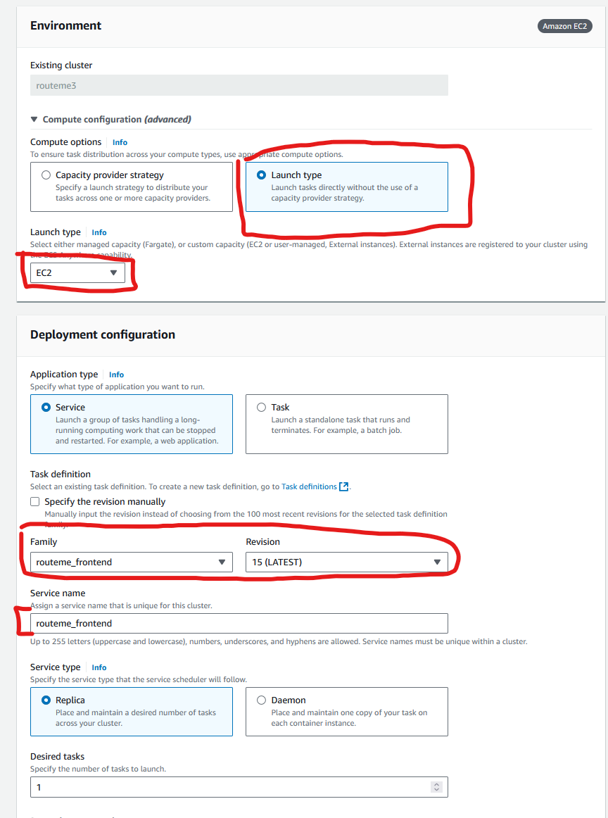
10. For “service connect” enable it. and click:  
    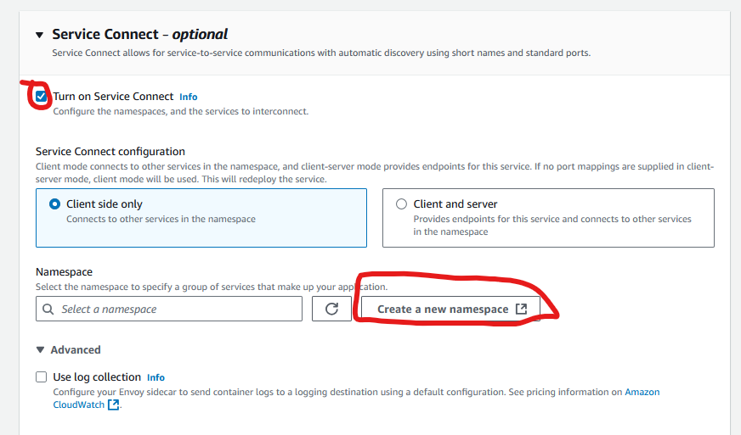
11. A new tab should have opened. Name it and click “create namespace”:  
    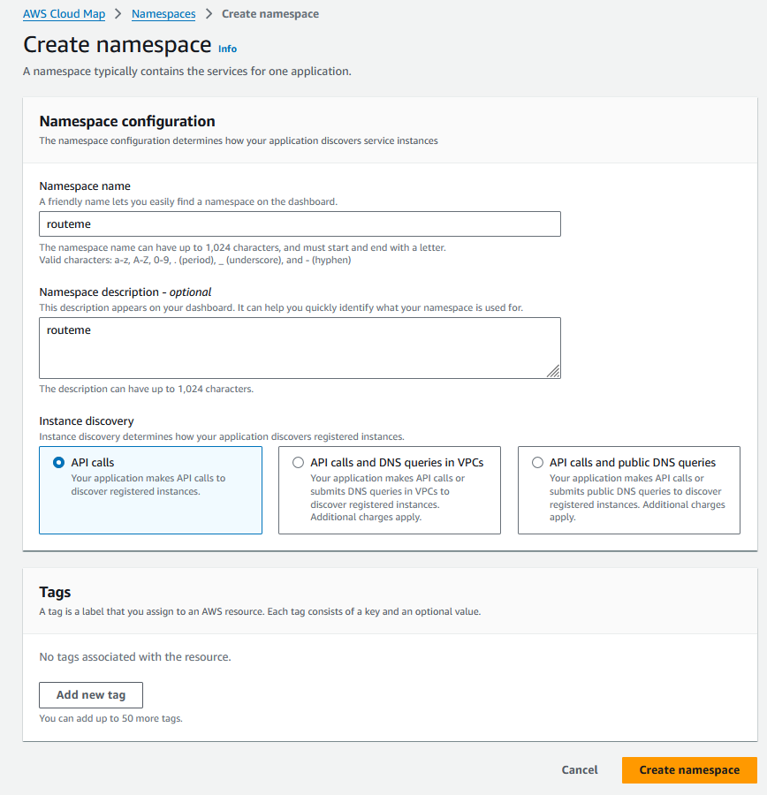
12. Now you have a “namespace” and can close this tab to go back to ECS service set up.  
    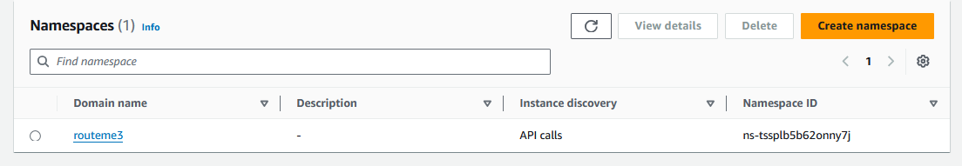
13. Refresh and select the new namespace:  
    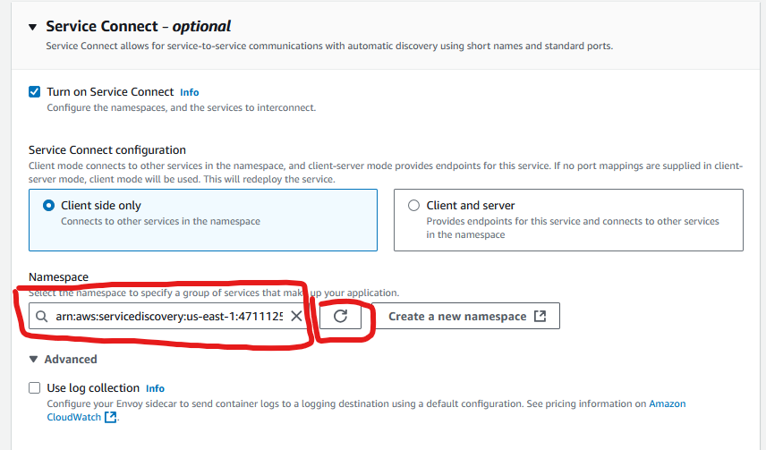

1. Assocaite the ALB:  
   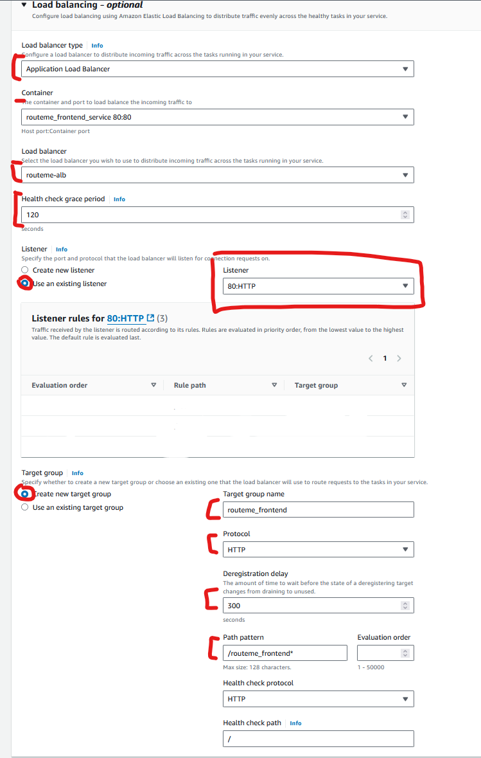
2. Repeat these steps to create the backend service:  
   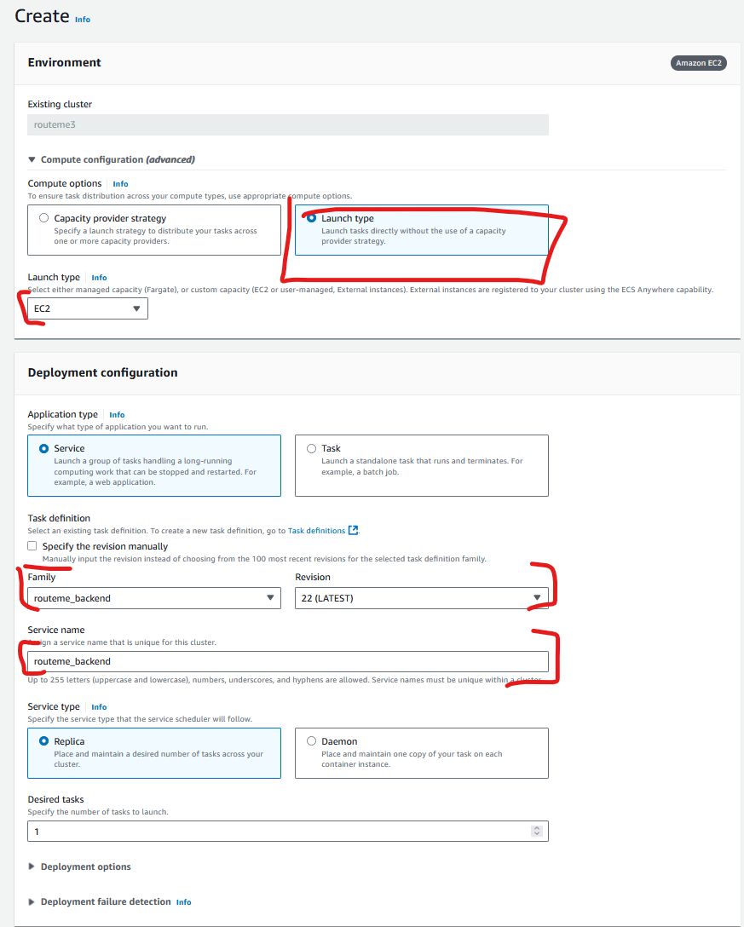  
   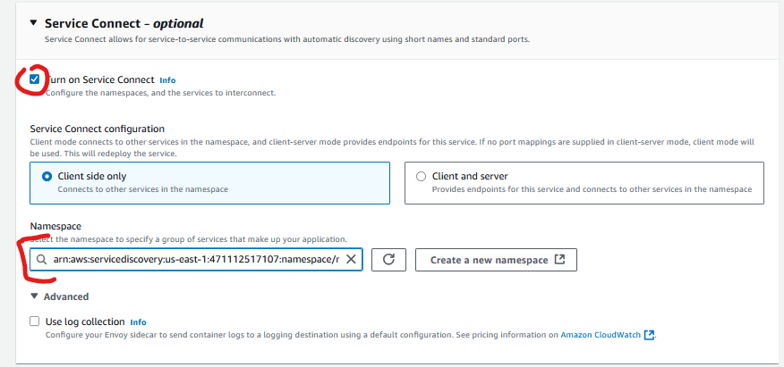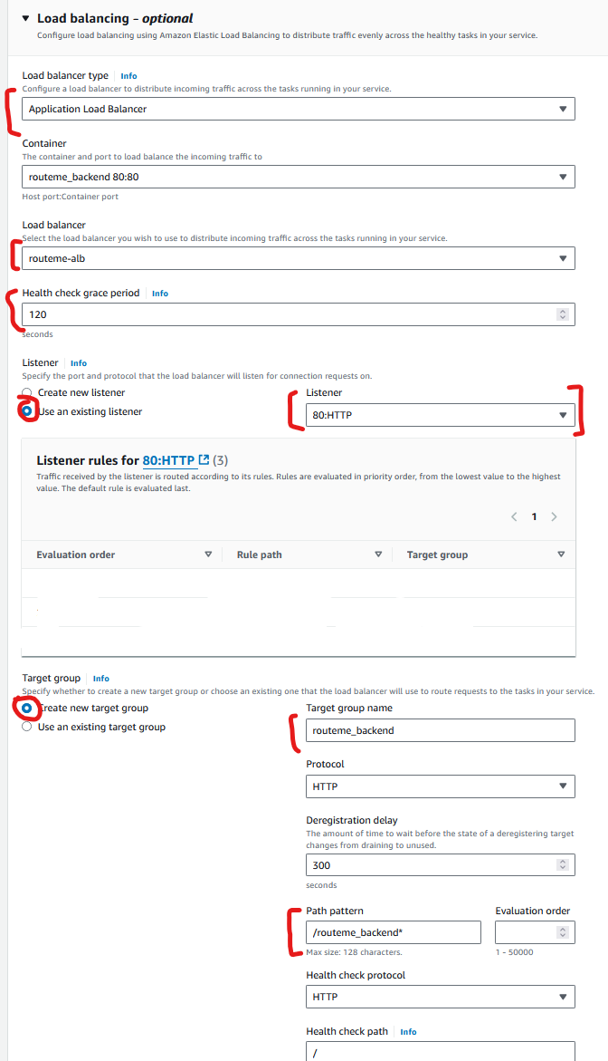
3. Repeat for MongoDB service:  
   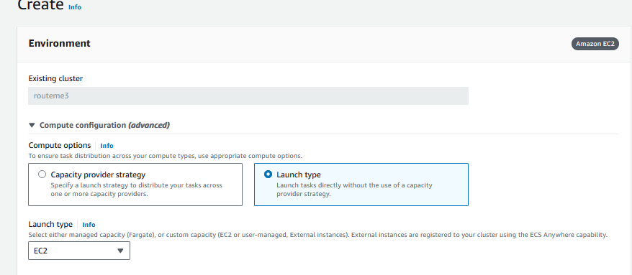

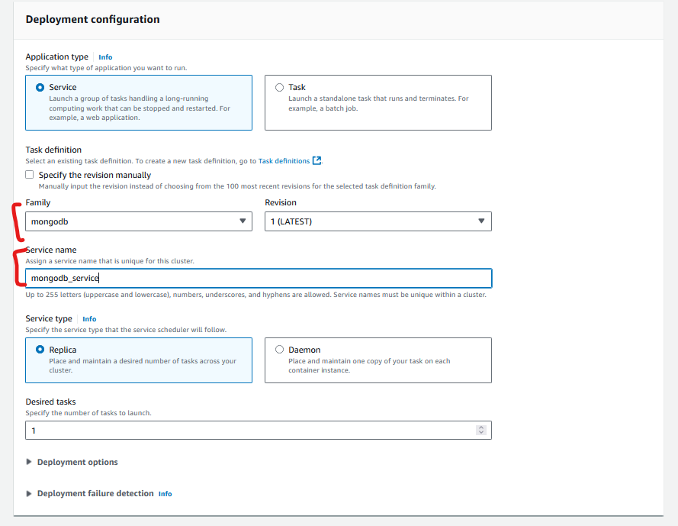

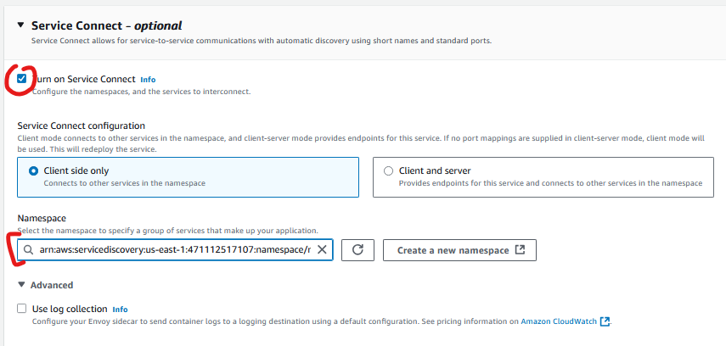

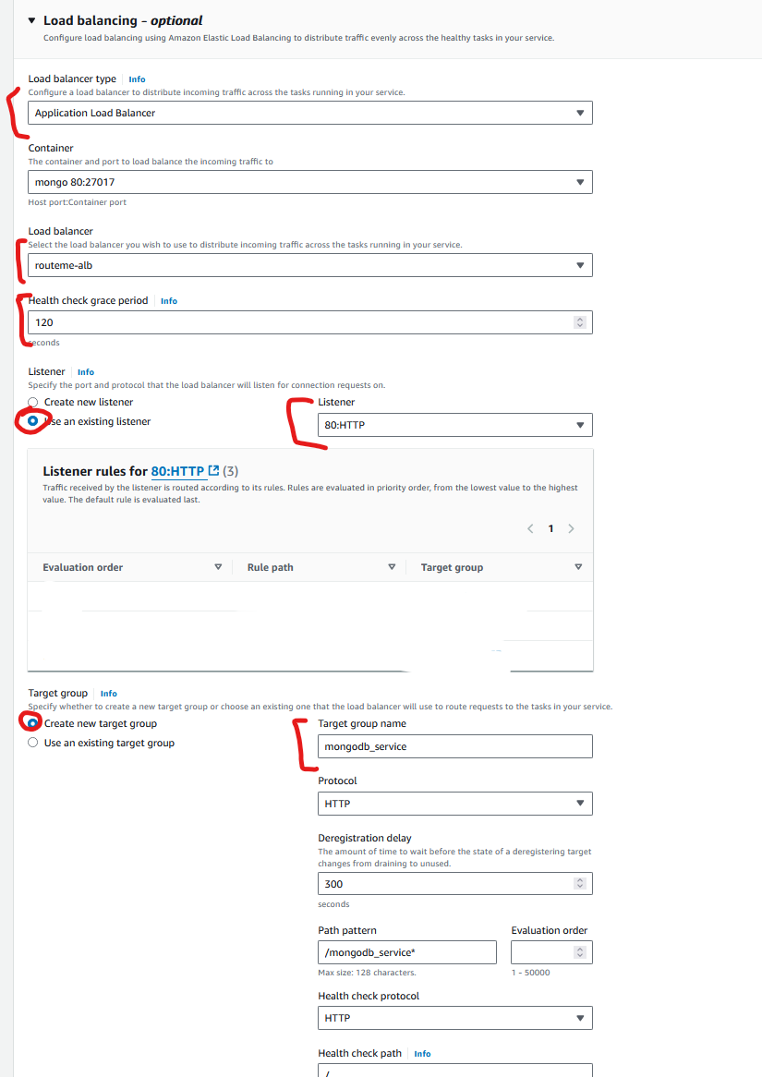

1. Eventually your services will be up and running and look like this:  
   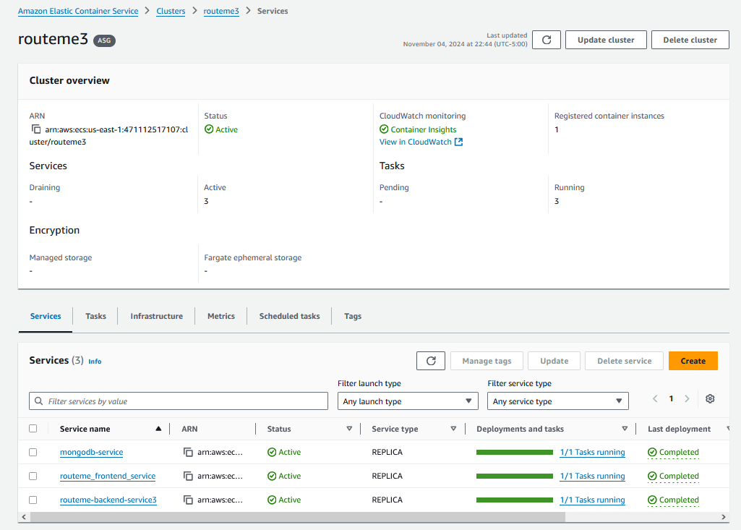

How to set up Google Maps API:

1. Go to “APIs & Services”:  
   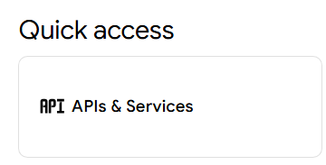
2. Click 
3. Enable the “Maps Javscript API” and “Routes API”:  
   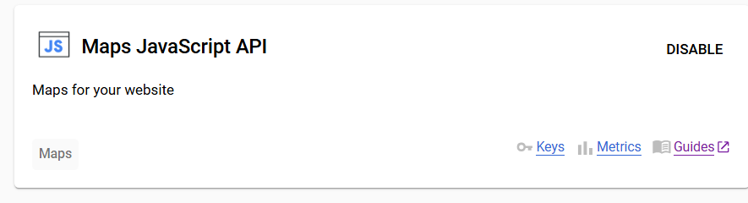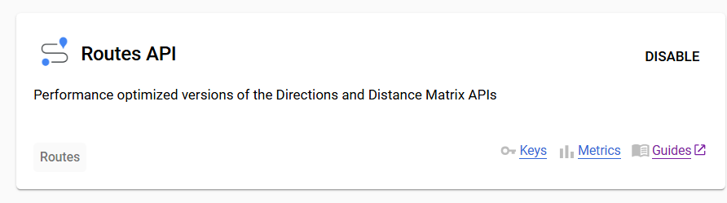
4. Go to “credentials”:  
   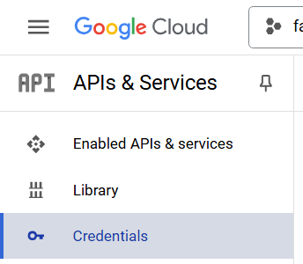
5. Click “Create credentials” and “API Key”:  
   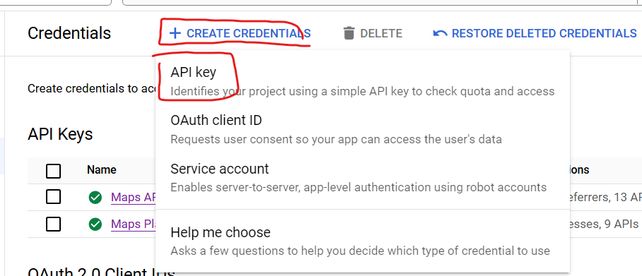
6. Save the API Key locally, you will need in your code: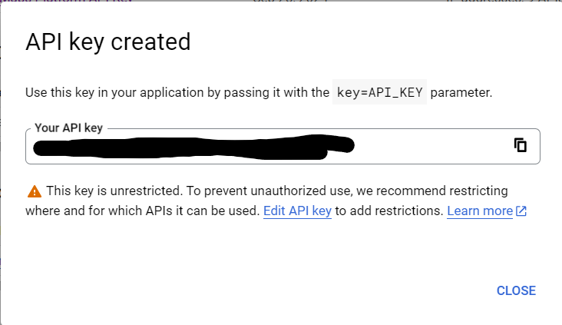
7. For the newly created key, click the three dots on the right and click “edit key”:  
   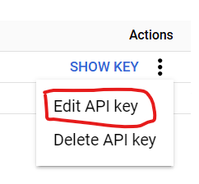
8. Name it appropriately, this will be used by the frontend service. Set an application restriction to “websites” and then add the ALB URL:  
   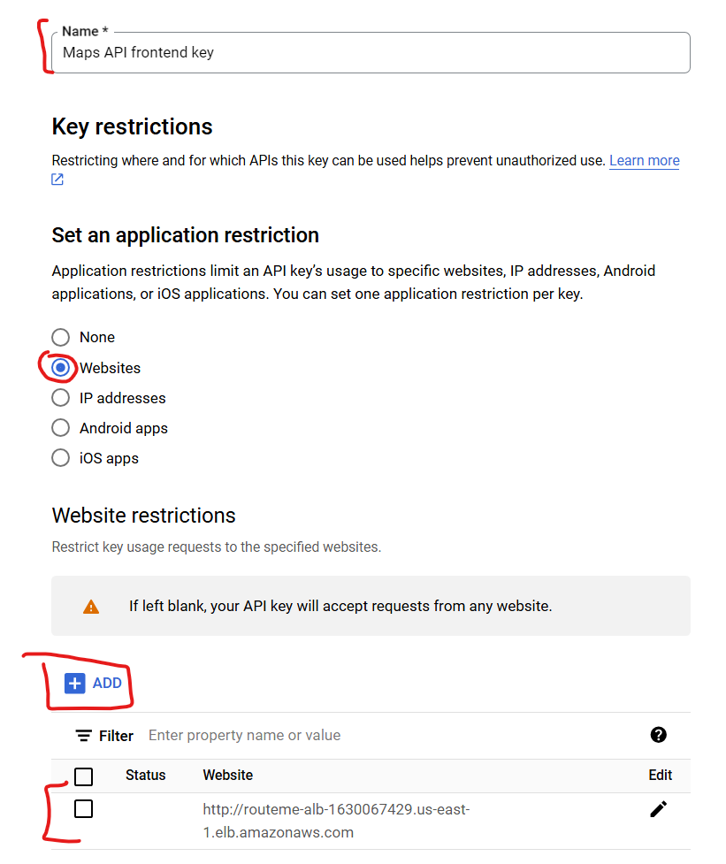
9. Click “save”:  
   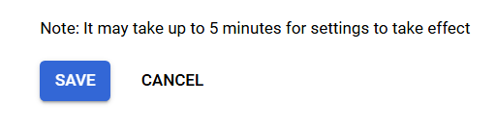
10. Create a second key the same way and save the credential:  
    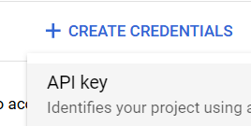
11. Edit the key:  
    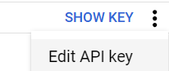
12. Name it appropriately. This Key is for the backend service. We will want to restrict this to the IP of the ECS instance that runs our ECS services. This can be found in AWS EC2 > instances.  
    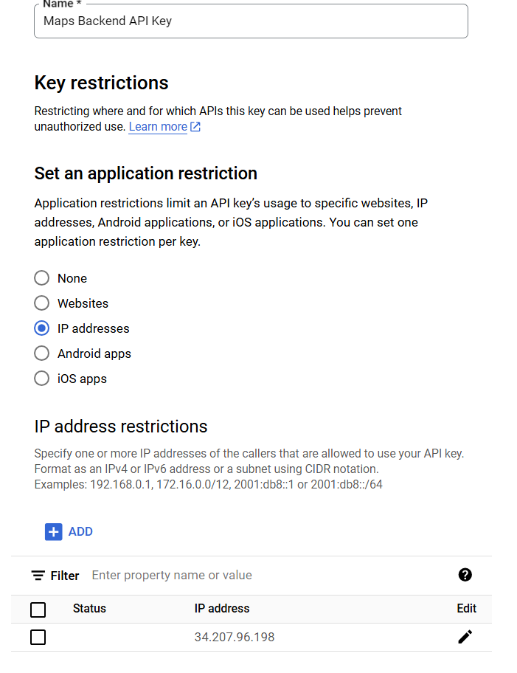  
      
    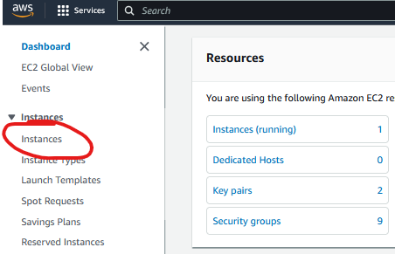

Select the instance:  
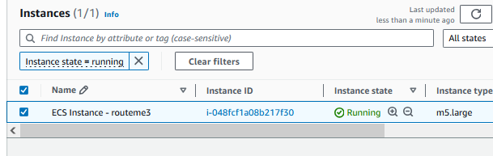

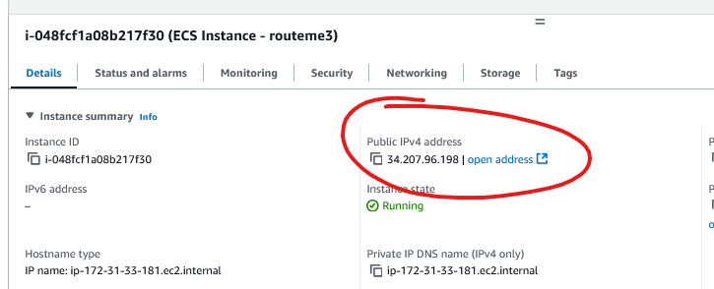

Here in the dashboard you can see the Google Map API being used:

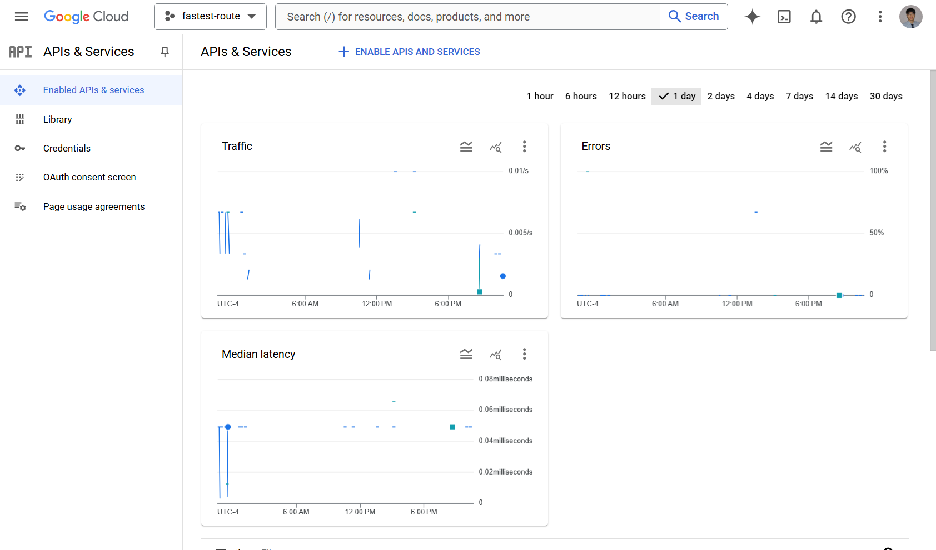

# Demo

Below are gifs of the project demo. Please view in Microsoft Word.



